Role Profile

Reference Number | 00646
Role Title | Head of Business Information (BI)
Directorate | Office of the Chief Executive
Department | West Yorkshire Pension Fund
Reports to | Chief Technology, Projects and Communications Officer

Role Purpose
Provide strategic leadership, direction and subject matter expertise in the development and delivery of BI services including monthly, quarterly and annual reporting analysis for WYPF SLT, WYPF Board and Advisory Panel.
Define the organisation’s information needs, developing BI strategies aligned with business goals, and selecting appropriate technology solutions.
Lead the design, development, and deployment of new BI systems, including data warehousing, analysis and reporting tools.
Provide both strategic and detailed commentary on BI bringing in context from a wide range of external sources e.g. LGA, DWP, external benchmarking to put performance into market context and provide strategic actionable insights.

Accountabilities
Provide strategic leadership, direction and subject matter expertise in the development and delivery of BI services including monthly, quarterly and annual reporting analysis for strategic directors and advisory panel.
Provide actionable insights from the above that will positively impact the organisation.
Defining the organization's data needs, developing MIS strategies aligned with business goals, and selecting appropriate technology solutions.
Leading the design, development, and deployment of new MIS systems, including data warehousing and reporting tools.
Leading the definition and creation of operational data standards, ensuring data integrity, and managing data access controls for BI.
Managing the budget allocated to BI operations and ensuring cost-effective technology utilization.
Develop and maintain working relationships with WYPF SLT and other senior officials to provide key performance indicators (KPIs) and data insights to decision-makers.
Working with auditors on the provision of information analysing risk issues and trend analysis.
Work with officers, both within WYPF and the Council, WYPF Governing Bodies, other Pension Fund services, external agencies, peer groups working to ensure the BI is at the forefront of informed decision making.
To provide strategic leadership in directing, developing and transforming West Yorkshire Pension Fund’s (WYPF) Business Information (BI) services.
Lead the development of the collection, analysis, and distribution of critical data to inform strategic decision-making by senior management, leading the development and implementation of the company's management information system (MIS) strategy; ensuring the data is accurate, timely, and actionable.
To devise, implement and provide accurate regulatory reporting for WYPF, ensuring its relationships/reputation are strengthened at a shared services and national level driving long-term advocacy from key stakeholders.

People
Develop a learning and high-performance culture, underpinned by linking with external organisations to provide non competing sharing of information, new technologies and associated knowledge transfer, driving innovation in WYPF management information.
Leading colleagues in data analysis, data modelling, data tooling and technical support for BI.
Leading, training and educating officers, both within WYPF and the Council, WYPF Governing Bodies, other Pension Fund services, external agencies, peer groups working corporately and cooperatively to ensure the BI service is at the forefront of informed decision making.
Leading, motivating and managing cross functional teams, establishing a positive performance culture that encourages staff to exceed expectations, delivers positive outcomes and continued service improvement and efficiency gains through the BI insights provided.
Leading and delivering change and improving systems through new ways of working in MI, engaging staff through a period of change to embed more effective performance monitoring and facilitating a culture of continuous improvement.
Responsible for the welfare, health and safety of staff within a designated area of responsibility, ensuring corporate standards are met.
Coach and mentor individuals within the organisation promoting high quality learning, ensuring the development of staff and assisting with career progression. Responsible for carrying out staff appraisals including the implementation and monitoring of staff development plans and appraisal targets.
Specific Accountabilities
To provide strategic leadership in developing and transforming West Yorkshire Pension Fund’s (WYPF) technology services to provide value for money, admin/operational capacity and end user efficient ways of working/interacting with the WYPF service.
Developing MI strategy and metrics needed to monitor business performance, aligning them with organizational goals.
Managing the collection of data from various sources, ensuring data quality, and conducting analysis to extract meaningful insights.
Delivering business insights and reporting creating comprehensive reports and dashboards to present data insights to senior management in a clear and accessible format.
Defining the technology required to create the MIS system and user access control.
Direct, manage and lead a technical specialist to deliver, innovative IT solutions to over 30 individual organisations and 700 Employers in consideration with complex business, legislative, regulatory and technical issues in a multibillion-pound financial services setting.
Regularly prepare and present appropriate reports to WYPF SLT, WYPF Board and Joint Advisory Group, Governance and Audit Committee.
Improve the reputation and organisational reach of WYPF through strategic visual communications techniques in advanced analytics and BI.

Knowledge / Skills / Experience required
Experienced data and information leader with a proven track record of transforming data, analytics and reporting capabilities within complex organisations.
Strong leadership skills, the ability to engage senior stakeholders, and expertise in data mining, analytics, information insight, and complex trend analysis including risk analysis.
Experience of operating in a large-scale business process out-sourcing environment.
Understands the working practices, procedures and basic operations across own specialist area and those of wider WYPF team to enable the provision of effective BI system
Uses specialist knowledge of regulations and legislation including risk in own area.
Uses a range of specialist technology across own work area and or across other areas of work including tooling, data modelling and AI.
Oversees a budget, keeping costs within agreed levels for own department and contributes to Corporate savings.
Uses, interprets, analyses and communicates complex information from a variety of sources.
Proven track record of succeeding in high pressure environments, creating and communicating a picture of the short, medium and long-term needs insights for top management. Demonstrating the ability to critically analyse risks.
Ability to set and manage significant workload and change agendas in own area. Developing planning, effective control and risk management in a highly regulated environment.
Proven experience in data transformation and governance within a large, complex organisation.
Strong leadership and stakeholder engagement skills.
Expertise in using data to drive operational improvements and decision-making.
Ability to lead cultural change and embed data value within the organisation.
Strategic thinker with the ability to navigate different priorities and department structures.

Relevant experience requirement: Will be used in shortlisting
Minimum of 5 years’ experience and background in leading, developing BI reporting and analytics functions, supplying quality business intelligence and trend analysis for Executive Officers and Committees to make informed and accurate business decisions from.
Significant experience of creating, developing and implementing BI strategies and technologies, plans, including decision processes and translation into operational plans.
Strong leadership and stakeholder engagement skills.
Expertise in using data to drive operational improvements and decision-making.
Ability to lead cultural change and embed data value within the organisation.
Relevant professional qualifications requirement: Will be used in shortlisting
A relevant degree in an IT discipline, or equivalent.
Demonstrate recent and continuing professional and personal development

Dimensions of role (direct/ indirect as applicable) eg total number of staff managed/ total budget/ total scope of role
Manage the access to highly confidential, personal, financial, political and commercially sensitive information; to ensure compliance with appropriate legislation e.g. GDPR, FOI, Child Protection Act, etc (and any UK replacement). The unauthorised disclosure of which would prejudice the interests of the Council.
Manage and lead the MI Technology, reporting and insight approx. 5000 users across scheme employers and 500,000 members, including operational reporting of 220 staff.

Staffing – 1 member of staff

Structure Chart (role of direct reports)
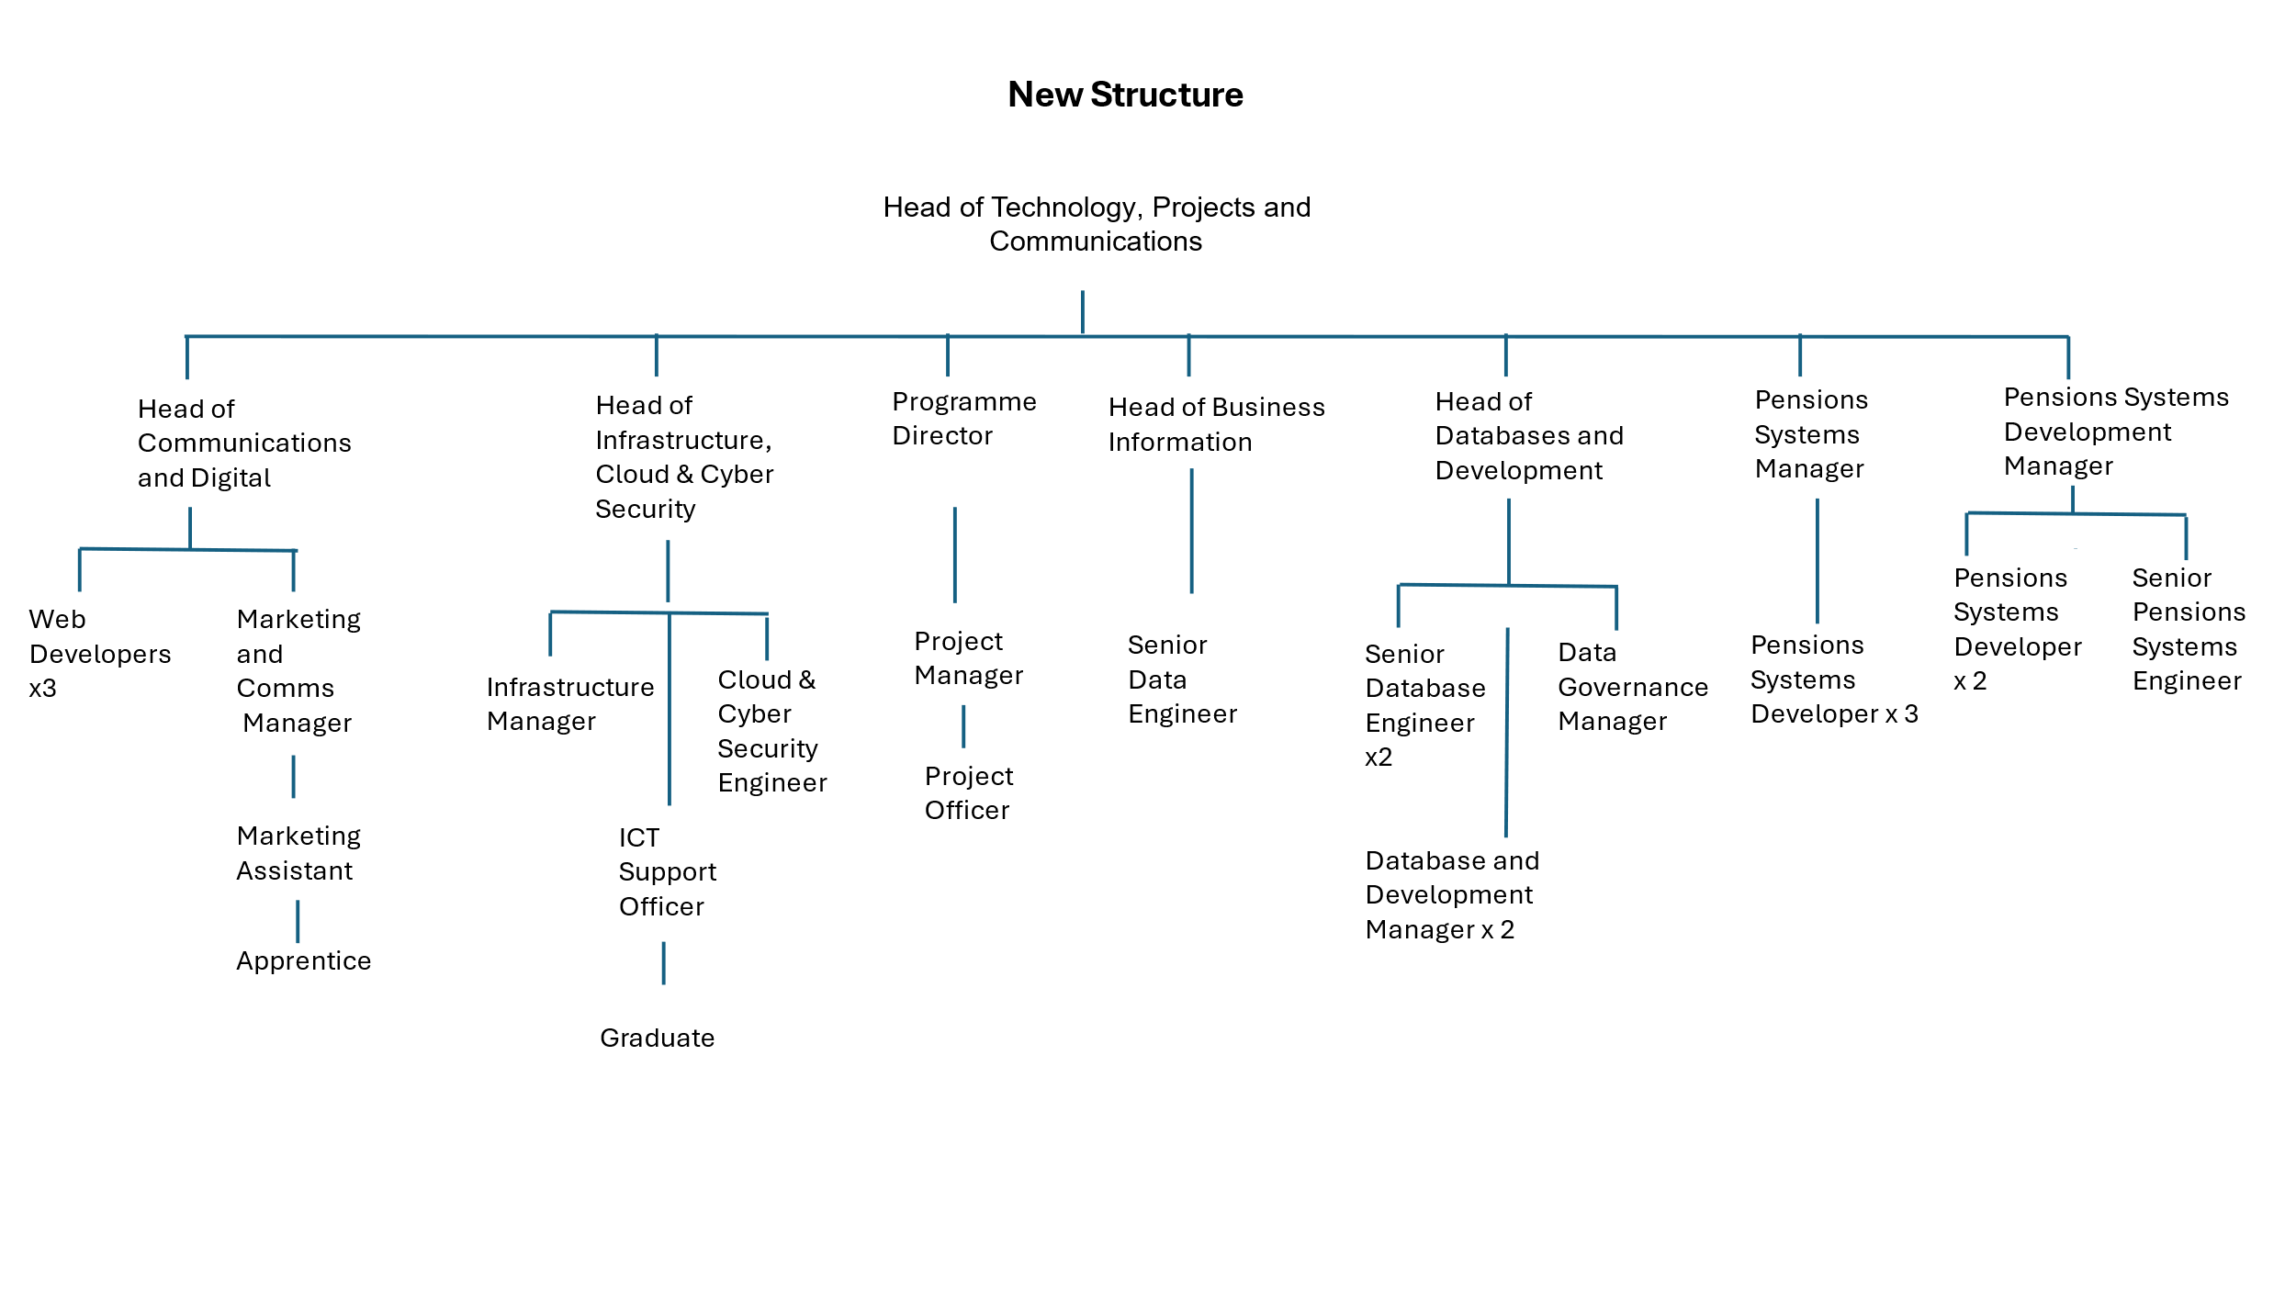

Key benchmarked competencies, traits and motives required to successfully deliver the role (not required for JE. Informs recruitment, succession planning, development and performance management
Operates with Strategic Awareness Our managers work with corporate priorities and policies in a joined up way with others, internally and externally. Works democratically, transparently and accountably.

Practices Appropriate Leadership Our managers motivate their staff to exceed expectations through raising their awareness of goals and moving them beyond self interest for the sake of the team or service. They consider serving the District in all that they do.

Delivering Successful Performance Our managers monitor performance of services, teams & individuals against targets & celebrate great performance. They promote the District’s vision & work to achieve Council’s values & agreed outcomes

Must be able to perform all duties and tasks with reasonable adjustment, where appropriate, in accordance with the Equality Act 2010 in relation to Disability Provisions.
Must be prepared to travel to address or participate in meetings, liaise with staff working in remote offices, undertake training both within and outside West Yorkshire. Must be able to work flexible hours as required by the needs of the service

The post will be subject to a DBS check.

