

**Fire Authorities**

**Monthly Data Exchange**

**Manual**

**Index Page**

1. Introduction 3
2. Contributions bands 3
3. Paying extra contributions 3
4. Completing your monthly data exchange 3
5. Submitting your monthly data exchange 7
6. Exception reports 9
7. Cumulative Pensionable Pay (CPP) 12
8. Assumed Pensionable Pay (APP) 12
9. Monthly data exchange spreadsheet template 13
10. **Introduction**

The monthly data exchange which you upload and submit gives us the core information which we use to create and maintain member records on our systems. It is used to set new starter records or opt-outs cases so you don’t have to complete any additional paper forms.

1. **Contributions**

All firefighter pension schemes now have tiered contribution bands based on the income of the firefighter. You should check these regularly as the bands are adjusted each April.

1. **Members paying ‘extra’ contributions**

From time-to-time members choose to buy additional 60ths (FPS 1992) or added pension (FPS 15) to improve their benefits. You should include the extra contributions you deduct and show them on the monthly data exchange.

1. **Completing your monthly data exchange**

A copy of the Data Exchange spreadsheet is available on request from WYPF.

Once you have saved the template to your own computer you can enter the information using a data download from your payroll system.

**Period and fire authority information**

|  |  |  |  |
| --- | --- | --- | --- |
| **PAYROLL_PD** | **PAYROLL_YR** | **EMPLOYER_LOC_CODE** | **EMPLOYER_NAME** |
| APR | 2017/18 | 1 | DUMMY EMPLOYER |
| APR | 2017/18 | 1 | DUMMY EMPLOYER |
| APR | 2017/18 | 1 | DUMMY EMPLOYER |
| APR | 2017/18 | 1 | DUMMY EMPLOYER |
| APR | 2017/18 | 1 | DUMMY EMPLOYER |

The **PAYROLL_PD** is the month for which the contributions have been deducted. You should enter the first three letters of the month only for example: Jan/Feb/Mar.

The **PAYROLL_YR** is the scheme year that the contributions are being deducted in and should show 2018/19 from 1 April 2018. And will then run the 1st April to 31st \march for each subsequent scheme year .

Your **EMPLOYER_LOC_CODE** is a unique number that is allocated to each fire authority, you can find your location number on the Firefighters website Notes.

Your code is important as it allows us to link the members that you are detailing in the spreadsheet to you as their fire authority. If you are submitting a return that contains members from multiple fire authorities you must ensure that the correct employer location code is used for each set of employees.

You will also need to enter the fire authority name in field **EMPLOYER_NAME**, this helps us to match the data and check whether the employer location code has been entered correctly.

**SCHEME_NAME** will show the relevant scheme related to the member 1992 2006 or 2015.

**Member personal data fields**

|  |  |  |  |  |  |
| --- | --- | --- | --- | --- | --- |
| **MEMBERS TITLE** | **SURNAME** | **FORENAMES** | **GENDER** | **DOB** | **RANK_ROLE** |

The members personal details fields ask for:

**MEMBERS_TITLE**

**SURNAME**

**FORENAMES**

**GENDER**

**DOB**

**RANK_ROLE**

Rank_Role must be shown in the exact format as one of the following;

Firefighter Trainee

Firefighter Development

Firefighter Competent

Crew Manager Development

Crew Manager Competent

Watch Manager Development

Watch Manager Competent A

Watch Manager Competent B

Group Manager Development

Group Manager Competent A

Group Manager Competent B

Station Manager Development

Station Manager Competent A

Station Manager Competent B

Area Manager Development

Area Manager Competent A

Area Manager Competent B

Assistant Chief Fire Officer

Deputy Chief Fire Officer

Chief Fire Officer

This information is really important to the matching process and allows us to allocate the data you supply to the correct members when they are uploaded to our administration system. If you have members with more than one job then the job title is used to ensure we match the data to the correct record.

|  |  |  |  |  |  |
| --- | --- | --- | --- | --- | --- |
| **ADDRESS1** | **ADDRESS2** | **ADDRESS3** | **ADDRESS4** | **ADDRESS5** | **POSTCODE** |

We also ask you to confirm the members current address, this is for information purposes only. Please use the Fire Portal to inform us of any address changes to ensure we are sending pension information to the correct member and address.

|  |  |  |  |  |
| --- | --- | --- | --- | --- |
| **COSTCODE** | **MEMBER_NO** | **NI_NUMBER** | **PAYREF** | **POSTREF** |

The **COSTCODE** is not a mandatory field and does not need to be completed. This is for fire authorities who want us to hold a cost code for reporting cost allocation information. For example, if you want to charge a particular department for any costs occurred for specific members.

The **MEMBER_NO** is also not mandatory, this is a unique reference allocated to each pension record a member has. This is one way we can ensure a 100% match between our systems and we are happy to provide you with this information to hold on your records. Please contact your Client Relationship Manager for this information.

The member’s **NI_NUMBER** and **PAYREF** will be used to identify the correct member to allocate data to, if you also allocate a **POSTREF** you can enter it on the monthly return, however this information is not mandatory.

**Hours fields**

|  |  |  |
| --- | --- | --- |
| **FT_PT_RT FLAG** | **STD_HOURS** | **CONTRACTUAL_HRS** |

You will need to enter an hours flag in the **FT_PT_RT FLAG** field, this will enable us to identify if the member is working full or part-time, you can enter one of the following:

* RT = Retained Firefighter
* FT = Full Time
* PT= Part Time

The **STD_HOURS** field is not mandatory but can be used to record the standard hours for the post, in most FRAs this will be 42.00

The members **CONTRACTUAL_HRS** are the hours that the member is contracted to work out of their full-time equivalent. For a member who works 21 hours out of 42 standard hours, please enter the decimal equivalent which would be121.00 in this field. For **RETAINED FIREFIGHTERS** the contractual hours should show as 0.00.

**Joiners and leavers fields**

|  |  |  |  |  |
| --- | --- | --- | --- | --- |
| **DATE_JOINED_SCHEME** | **ENROLMENT_TYPE** | **DATE_OF_LEAVING_SCHEME** | **OPTOUT_FLAG** | **OPTOUT_DATE** |
| 01/04/2016 | CONTRACTUAL |  |  |  |
| 01/10/2016 | AUTO |  |  |  |
| 01/09/2016 | CONTRACTUAL |  |  |  |

If you have new joiners within the period then you will need to provide a **DATE_JOINED_SCHEME**, this will allow us to create a record for the member and will mean that you do not have to submit a starter form. You will also need to tell us if the member has been contractually enrolled under the scheme regulations or whether the member has been brought into the scheme due to overriding Auto-enrolment legislation. In the **ENROLMENT_TYPE** please enter either **CONTRACTUAL** or **AUTO**.

If the member is leaving the scheme within the month that you are returning the data for, please give us the date of leaving here DATE**_OF_LEAVING_SCHEME**. Although this does not replace the Leaver notification it does mean that we’re aware of when a member leaves the scheme and we can ensure that leavers’ information is collected.

If the member has opted out of the scheme within the first 3 months and you have refunded the money to them via your payroll system please indicate that they have opted out in the **OPT_OUT FLAG** field by entering **CONTRACTUAL** or **AUTO** depending on whether the member opted out under the scheme regulations (contractual) or under the overriding auto-enrolment legislation (auto).

**Pay and contributions fields**

|  |  |  |  |  |
| --- | --- | --- | --- | --- |
| **PENSIONABLE_PAY (1992,2006)** | **PENSIONABLE PAY 2015 Career Average** | **EE_CONT_MAIN** | **APB_FOR_TEMPORARY_PROMOTION** | **CPD_TOT_PEN_EE_CONTS** |
| £2,972.67 |  | £202.14 |  |  |
| £2,973.67 |  | £202.21 |  |  |

**PENSIONABLE_PAY_1992_2006_SCHEME** is the pay the member has received in the employment during the month excluding Temporary Promotion & CPD. Final Salary schemes only.

You will need to advise us of any periods of unpaid leave

Please note that if you have any employees with temporary promotions that started before the 1st July 2013 you will need to include this pay in the employee’s pensionable pay.

.

2015 CARE pay – this is the actual pensionable pay received as a member of the 2015 scheme, and should include CPD.

This field should be blank for any member who has not transitioned into the 2015 scheme by 31 March.

The CARE pay should be made up to Assumed Pensionable Pay i.e. a notional pay figure for absence under the following circumstances:

* trade dispute
* authorised unpaid absence
* reserve forces service leave
* child-related leave
* illness or injury leave
* ordinary adoption leave
* ordinary maternity leave
* paternity leave

if the fire-fighter has received reduced pay for any reasons- see here for full details of how APP should be calculated in the circumstances detailed above.

**EE_CONT_MAIN** is the employee contributions (if any) that have been deducted from the pay within the period.

**APB_FOR_TEMPORARY_PROMOTION_CONTS** is the total contributions deducted in respect of the APB for temporary promotion. This should include

Ee's Conts + Er's Conts + Notional Conts for the Ill Heath Element. Final Salary schemes only.

**CPD_TOT_PEN_EE_CONTS** is the pensionable continuous professional development contributions the member has paid. This should include Ee's Conts + Er's Conts + Notional Conts for the Ill Heath Element. Final Salary schemes only.

|  |  |  |  |  |
| --- | --- | --- | --- | --- |
| **PRCHS_OF_60TH** | **ADDED_PENSION_CONTRIBUTIONS** | **ANNUAL_RATE_OF_PENSIONABLE** | **AVERAGE_PENSIONABLE_PAY** | **NOTES** |
|  |  | £35,672.00 |  | £2.05 |
|  |  | £35,684.00 |  | £120.33 |

**PRCHS_OF_60TH** are the members contributions paid to purchase extra 60th’s (FPS 1992 and 2006)

**ADDED_PENSION_CONTRIBUTIONS** (FPS 2015)

**ANNUAL_RATE_OF_PENSIONABLE** _PAYis the notional full time equivalent rate of pay taken from the salary scales. **This must be provided for the March data exchange if it is not provided for other months.**

**AVERAGE_PENSIONABLE_PAY –** this is the pay we will use to calculate the final salary pension benefits on the Annual Benefit Statement.

- For whole time members of the 1992, 2006 and RDS Modified Schemes who have not lost any pay during the year this will be the same as supplied in column L.

- If they have lost any pay then it should be made up to what they would have received for 365 days (similar to APP in the LGPS). This would include any pay lost due to strike.

- For part time members it is the whole time equivalent for 365 days.

- For retained members this is the reference pay. If the fire-fighter has not changed role during 16/17 then the reference pay is as per the attached document. If they have changed roles then the reference pay is an individual amount based on the date of change.

**Adding notes**

You can add notes to your spreadsheet to let us know any information that will help us to reconcile your return, this could be a period of absence or information on a period of long term sick, or other exceptional issues that will explain discrepancies.

|  |
| --- |
| **NOTES** |
|  |
|  |
|  |

We will not use the information you provide in the notes column to make any amendments to a member’s record, it is purely used to help understand any discrepancies.

1. **Submitting your monthly data exchange**

To submit your monthly data exchange you will need to login to the secure administration facility by clicking on Monthly Return on the Employers Firefighters’ home page. Select “Combined monthly return and remittance advice (REMAD)” located under completing your monthly return, and this will take you to our secure website.

To use the secure website you need a login name and password. If you don't already have these please complete the secure administration - user agreement form and make sure you are added to either the Main contact registration form or Authorised user list.

<http://www.wypf.org.uk/Employer/Forms/Employer/EmployerFormsPDF/secureAdministrationAgreement.pdf>

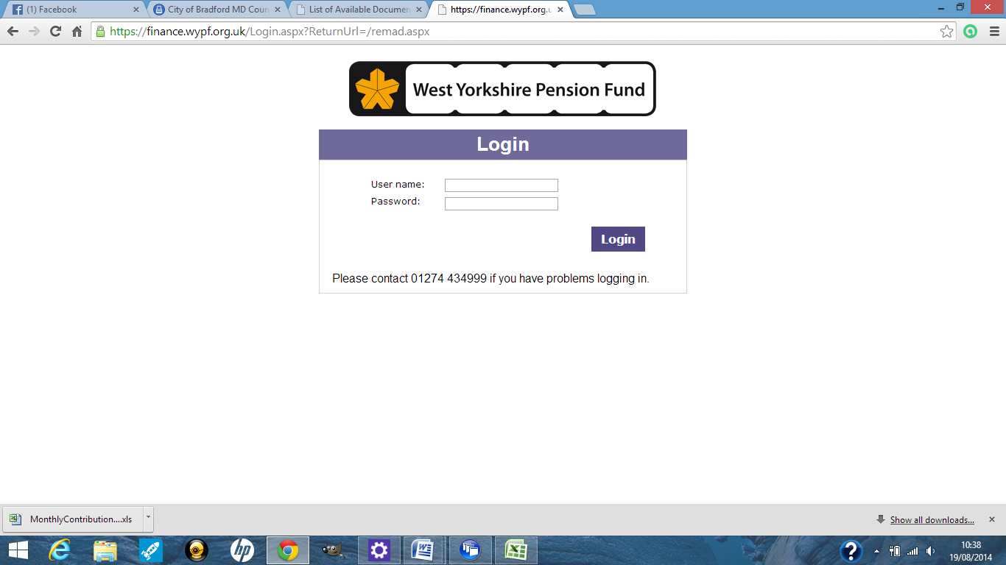

Enter the login name and password that you have been issued and then click login.

This will take you to the remittance advice where you can enter the details for the return you are submitting.

Check that your user name and the fire authority you are submitting information for is correct.

If you are a payroll provider, select the name of the FRA that you are working for.

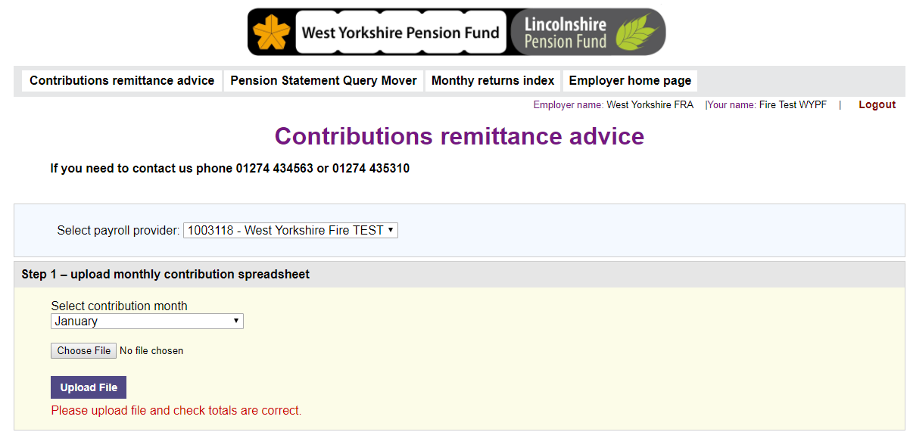

Select the month you are submitting the return for and then click on choose file.

Select the monthly contributions file from your computer and click on upload file, you will receive the message "file uploaded successfully" if your upload has worked.

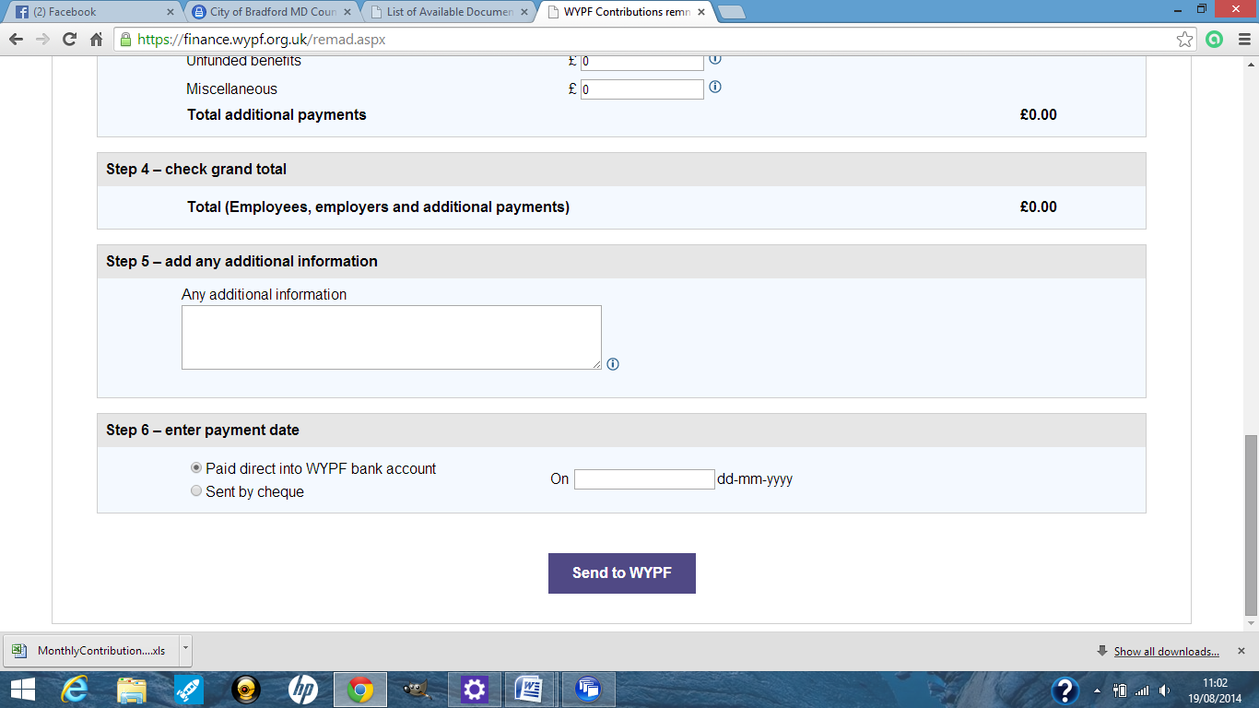

Finally click "Send to WYPF"

1. **Dealing with exception reports**

When your monthly data exchange has been processed we will send your finance contact an e-mail letting them know that your data exchange is finalised and whether you have any exception reports available to view. These exception reports are held on the Firefighter portal.

You should use the username and password issued by WYPF to access both the Firefighter portal and the Monthly Data Exchange.

Once you have logged in to the Employer Portal you will see on the left hand menu “View Location Details”, click here and chose the pay location of the fire authority that you want to pick up the reports for. Of the 4 tabs click on View Documents, you will then see the exception reports and some other documents listed in date order. You can open the exception report by clicking on view document. The report will then open in Excel once you select “click here to open document in the new window”.

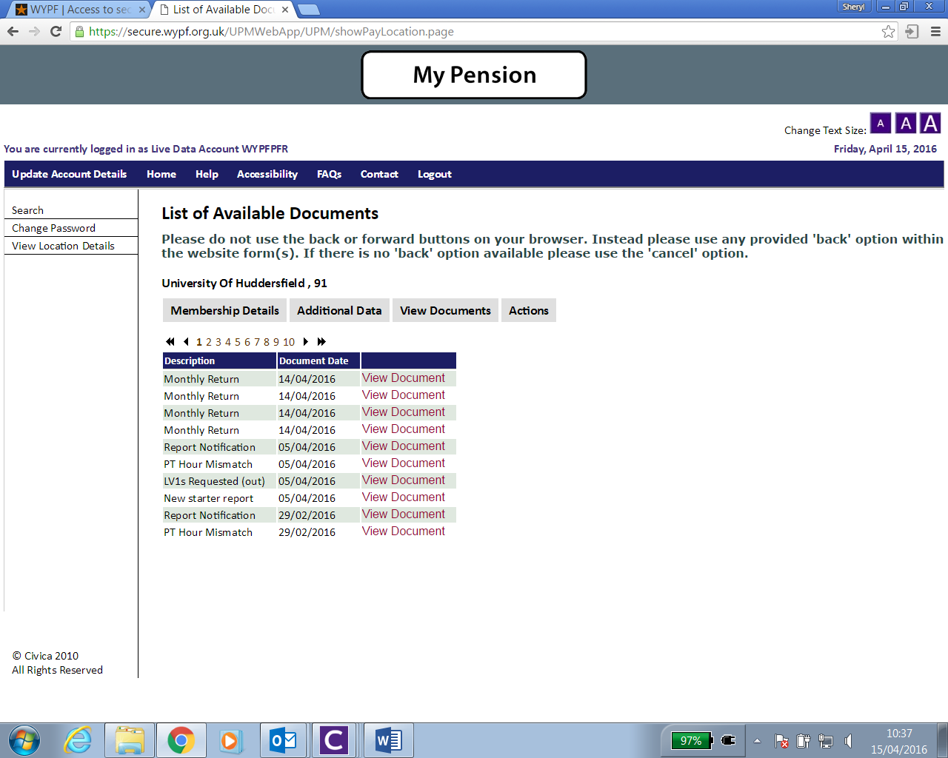

New screen print NOT university of Huddersfield !!

The documents produced from the exception reports are listed below. These are the ones you need to look at.

**PT Hour Mismatch**

When we have processed your monthly data exchange we compare the information that you have provided against the information that we hold on our system. If we have matched a record but the hours that you have provided don’t match our system a PT Hours Mismatch will be created. You should look at each of these errors and provide WYPF with the correct information. You only need to view the most recent PT Hours Mismatch Report.

For straight forward hours changes you can just add the date of the change to the spreadsheet and return to us for processing. For more complicated hours changes please send us the record maintenance web form. You should NOT include notes or change any of the columns on the PT Hours Mismatch spreadsheet. If you need to add notes please complete the record maintenance web form. You should ensure that all members on the spreadsheet have been completed with a date of change.

Hours are represented as decimals. We will record 15 hours and 45 minutes as 15.75.

If you have previously sent us a RM form for a member they will be excluded from the report, so will casual members and those on career breaks. You can find more information about submitting forms via the Firefighter portal [***here.***](http://www.wypf.org.uk/Employer/SecureAdministration/Manual/EmployerPortalManual.pdf) ***New link needed***

**New starter report**

If we can’t find a match for a member on your monthly return with the members on our systems we will create them a new record and set them up as a new starter. You don’t need to send us any further information for these members, you only need to check that everyone on the list is a genuine new starter and has not been set up in error. If you are happy with all of the members on your new starter report you do not need to do anything. If you have members who have been set up in error please contact us so that we can arrange for them to be deleted.

***Common problems***

We have noticed a few instances that can cause a new starter to be created when they should be a continuation of jobs:

* Promotions/change of job within the same organisation – if the employment is consecutive and the pay has increased please just amend the payroll number and job title if necessary and provide the information for the month of change on one single line for both posts
* If the member has a change of payroll number or job title part way through the month, do not create an additional line.

**LV1s Requested (out) (Leaver Forms)**

If you have told us that a member has left the pension scheme or a member no longer appears on your monthly data exchange but we still hold an active record for them, we will notify you that we need a leaver notification completing.

you can do this via the Firefighter portal, you can find out how to do this [here](http://www.wypf.org.uk/Employer/Firefighter/Firefighters_EmployerHome.aspx).

If the member has not left the scheme, please provide WYPF with an explanation of why they do not appear on the monthly data exchange.

1. **Cumulative Pensionable (CARE) Pay (CPP)**

In order to complete estimates under the new scheme rules we will ask for “cumulative pensionable pay”

This is the Pensionable Pay (PP) and/or Assumed Pensionable Pay (APP) built up in the Scheme year for members of the FPS 2015

This includes the value of payments specified in the contract of employment as being pensionable ( See here for details.

The cumulative amounts should contain all of the Pensionable Pay and/or Assumed Pensionable Pay during the year.

1. **Assumed Pensionable Pay (APP)**

This replaces “notional pay” in cases of reduced contractual pay or nil pay as a result of sickness or injury; or during relevant child related leave (i.e. ordinary maternity, paternity or adoption leave and any paid additional maternity, paternity or adoption leave); or whilst on reserve forces service leave. See APP notes for further information