

**Monthly Contributions Manual**

**MC3**

**Index Page**

1. Introduction 2
2. Payment dates 3
3. Payment methods 3
4. Paying over extra contributions 4
5. Contributions bands 5
6. Completing your monthly return spreadsheet 5
7. Submitting your monthly return 10
8. Tupe members 14
9. Exception reports 24
10. Process mover 27
11. Cumulative Pensionable Pay (CPP)  27
12. Assumed Pensionable Pay (APP) 27
13. Appendix. A Bank account details 29
14. Appendix. B Definition of pensionable pay

2013 & 2008 regulations 31

1. Appendix. C Trouble shooting errors and warnings 33
2. Contact information, PFR & Finance Business Partners 46
3. **Introduction**

When you pay across your members’ contributions to us every month, you send us a remittance advice and the monthly return spreadsheet to help us identify the payment and split the contributions between members and employers.

This makes the process of contributions management easier and ensures any problems with contributions are resolved as soon as possible.We will post data received and reconcile payments made by employers to member records each month.

The monthly return gives us core information that allows us to improve member records on our systems. The monthly return also means that you no longer need to inform us separately of new starters.

Any new starters will receive a welcome pack directly to their home address from the pension fund once their record has been created using your information supplied on your monthly return.

1. **Payment dates**

You can pay contributions over at any time before the deadline of the 19th of the month immediately following the month in which you made the deductions. If the 19th is a weekend or a bank holiday, the due date becomes the last working day before the 19th. In other words, we must receive June 2025 contributions by 18 July 2025 at the latest as the 19th is a Saturday. The schedule below sets out the payments dates for **2025/26**.

Contributions

|  |  |  |
| --- | --- | --- |
| Contributions deducted during … | Due date | Comments |
| **April 2025** | **Monday 19-May-25** |  |
| **May 2025** | **Thursday 19-Jun-25** |  |
| **June 2025** | **Friday 18-Jul-25** | **19 July is a Saturday** |
| **July 2025** | **Tuesday 19-Aug-25** |  |
| **August 2025** | **Friday 19-Sep-25** |  |
| **September 2025** | **Friday 17-Oct-25** | **19 October is a Sunday** |
| **October 2025** | **Wednesday 19-Nov-25** |  |
| **November 2025** | **Friday 19-Dec-25** |  |
| **December 2025** | **Monday 19-Jan-26** |  |
| **January 2026** | **Thursday 19-Feb-26** |  |
| **February 2026** | **Thursday 19-Mar-26** |  |
| **March 2026** | **Friday 17-Apr-26** | **19 April is a Sunday** |

**Late payments**

If your organisation regularly pays contributions late we will report this to the Pensions Regulator. We will charge interest on late payments in line with the regulations and we may charge your organisation for the cost of chasing the late payment.

1. **Payment methods**

See **Appendix. A** for the different payment methods used for West Yorkshire employers, Lincolnshire employers, London Borough of Hounslow employers and London Borough of Barnet employers.

1. **Paying over extra contributions**

From time-to-time members choose to pay extra contributions to improve their benefits. We set up the arrangements for members to pay extra. You must not deduct additional contributions for a member unless we or one of the Additional Voluntary Contributions (AVC) providers Scottish Widows (WYPF only), Prudential (WYPF, Lincolnshire & Barnet) or Standard Life (Hounslow) ask you to. When you get instructions to set up a new deduction it will be clear where the additional contributions should be paid. You should include the following extra contributions that are due on the monthly return:

* Buying extra pension through Additional Regular Contributions
* Buying extra partner’s survivor pension for a nominated cohabiting partner
* Buying extra scheme membership

Extra contributions for Additional Voluntary Contributions must be paid to the appropriate AVC Plan provider. The details of each provider and the fund in which they are approved for are below:

**Scottish Widows (approved for West Yorkshire members only)**

Please send your payment, accompanied by a payment schedule, which must show the employers unique reference number, along with the names, National Insurance numbers and amounts of each member’s deduction to:

**Scottish Widows PLC**

**West Yorks AVC Plan P24425**

**15 Dalkeith Road**

**Edinburgh**

**EH16 5BU**

Scottish Widows allocates a unique payment reference for each employer, please use this and not the scheme number when sending in payments and payment schedules. For more information about making payments to Scottish Widows please contact 03457 556 557 or email:

**localgovt.avc@scottishwidows.co.uk**

**Prudential (approved for West Yorkshire, Lincolnshire and London of Borough of Barnet members only)**

Prudential will give you details of the payment arrangements when setting up a deduction.

**Standard Life (approved for London Borough of Hounslow members only)**

Standard Life will advise you of the details you will require.

1. **Contribution bands**

From 1st April 2025 the contribution bands and the pay that members pay these contributions on are shown on the table below.

You need to deduct pension contributions based on the pensionable pay the member is **actually receiving**.

1. **Completing your monthly return spreadsheet**

The monthly return spreadsheet can be downloaded from the employer zone of our website.

The spreadsheet is kept in the Online portals box under more information. You can [download a copy of a blank monthly return spreadsheet here.](https://www.wypf.org.uk/lgps-employer-zone/employer-portals-and-mc3/)

Once you have saved the spreadsheet, you can enter the information using a data download from your payroll system.

**Excel spreadsheet errors when uploading**

An Excel file can be tricky to handle, there can be various scenarios where a cell formatting can break the data structure and cause errors to appear when uploading. Below are some examples of what **not** to do with your spreadsheet.

For example:

• Cell merge,

• Cell format, i.e. Currency, date, etc,

• Formula,

• Styling- bold/italic/highlight, special fonts, symbols,

• Adding ‘ before the contents,

• Adding “, £ before the amount data

• Empty rows at the bottom

• Multi line data in a single cell

• Trailing / leading spaces

**Payroll period and employer information**

|  |  |  |  |
| --- | --- | --- | --- |
| **PAYROLL_PD** | **PAYROLL_YR** | **EMPLOYER_LOC_CODE** | **EMPLOYER_NAME** |
| APR | 2025/26 | 1 | DUMMY EMPLOYER |
| APR | 2025/26 | 1 | DUMMY EMPLOYER |
| APR | 2025/26 | 1 | DUMMY EMPLOYER |
| APR | 2025/26 | 1 | DUMMY EMPLOYER |
| APR | 2025/26 | 1 | DUMMY EMPLOYER |

The **PAYROLL_PD** is the month which the contributions have been deducted. You should enter the first three letters of the month only for example: Jan/Feb/Mar.

The **PAYROLL_YR** is the scheme year that the contributions are being deducted in and should show 2025/26 from 1 April 2025.

Your **EMPLOYER_LOC_CODE** is a unique code that is allocated to each individual employer. You can find your employer code once you are logged in to the employer portal under View Location Details and then Paylocation.

Your employer code is important as it allows us to link the members that are on the spreadsheet to you as their employer. If you are submitting a return that contains members for multiple employers, you must ensure that the correct employer code is used for each set of employees.

You will also need to enter the employer name in field **EMPLOYER_NAME**; this helps us to match the contributions and allows us to check whether the employer location code has been entered correctly.

**Member personal data fields**

|  |  |  |  |  |  |
| --- | --- | --- | --- | --- | --- |
| **MEMBERS TITLE** | **SURNAME** | **FORENAMES** | **GENDER** | **DOB** | **JOBTITLES** |

**MEMBERS TITLE**

**SURNAME**

**FORENAMES**

**GENDER**

**DOB**

**JOBTITLES**

This information is really important to the matching process and allows us to allocate the contributions to the correct members when they are uploaded to our administration system. If you have members with more than one job, then the job title for each post lets us know which post each set of contributions are for.

**Address fields**

|  |  |  |  |  |  |
| --- | --- | --- | --- | --- | --- |
| **ADDRESS1** | **ADDRESS2** | **ADDRESS3** | **ADDRESS4** | **ADDRESS5** | **POSTCODE** |

We also ask you to confirm the member’s address which is then compared to the address we currently hold on our system. If it’s completely different we will automatically update our records to match the address you have supplied, however if there is a slight discrepancy we will send an e-mail to the administration contact asking for them to confirm which address is correct.

|  |  |  |  |  |
| --- | --- | --- | --- | --- |
| **COSTCODE** | **MEMBER_NO** | **NI_NUMBER** | **PAYREF** | **POSTREF** |

The **COSTCODE** is not a mandatory field and does not need to be completed. This is for employers who want us to hold a cost code for reporting cost allocation information. If you are currently allocating employee costs to financial accounting cost codes, you will be aware of the cost codes that you want for this purpose.

The **MEMBER_NO** is also not mandatory, this is a unique reference allocated to each pension record a member has. This is one way we can ensure a 100% match between our systems and we are happy to provide you with this information. Please contact your Employer Pension Fund Representative who can run a report to show the member numbers we hold for your employees.

The members **NI_NUMBER** and **PAYREF** will be used to identify the correct member to allocate contributions to, if you also allocate a **POSTREF** you can enter it on the monthly return, however this information is not mandatory.

If you have to use a temporary NI Number, please use the prefix TN. This will need updating on your monthly return once you have the members correct NI number. If the return is still showing a temporary number after 3 months, then the pension account will be closed and the contributions refunded.

We need the correct NI number to manage pension accounts; the advice from HMRC is that employers leave the NI field blank on the Full Payment Submission (FPS). If this is left blank and new employees have applied for NI number, this will be provided to employers along with a tax code. NI applications take a maximum of 4 weeks to be provided, unless there are queries.

**Hour fields**

|  |  |  |  |
| --- | --- | --- | --- |
| **FT_PT_CS FLAG** | **FT_PT_HOURS WORKED** | **STD_HOURS** | **CONTRACTUAL_HRS** |

You will need to enter an hour’s flag in the **FT_PT_CS FLAG** field, this will enable us to identify if the member is working full or part-time, or is casual. You can enter one of the following:

* CS = Casual
* FT = Full Time
* PT= Part Time

The **FT_PT_HOURS WORKED** field is not mandatory but can be used to record the number of hours the member has actually worked within the period. This information will allow validation checks to be carried out and will result in less exceptions being raised. For example, if the pay has increased significantly the member may have worked a number of additional hours which will account for the increase.

In the **STD_ HOURS** field you will need to enter the full-time equivalent hours for that members’ post, in most cases this will be 37, however is could be less (32.5 for nursery nurses) or it could be more depending on your organisation.

The members **CONTRACTUAL_HRS** are the hours that the member is contracted to work out of their full-time equivalent. For a member who works 18 hours and 30 minutes out of 37 standard hours, please enter the decimal equivalent which would be 18.50 in this field.

**Starter and leaver fields**

|  |  |  |  |  |
| --- | --- | --- | --- | --- |
| **DATE_JOINED_SCHEME** | **ENROLMENT_TYPE** | **DATE_OF_LEAVING_SCHEME** | **OPTOUT_FLAG** | **OPTOUT_DATE** |
| 01/04/2025 | CONTRACTUAL |  |  |  |
| 01/04/2025 | AUTO |  |  |  |
| 01/04/2025 | CONTRACTUAL |  |  |  |

If you have new starter within the period then you will need to provide a **DATE_JOINED_SCHEME**, this will allow us to create a record for the member. You will also need to tell us if the member has been contractually enrolled under the LGPS regulations or whether the member has been brought into the scheme due to overriding Auto-enrolment legislation. In the **ENROLMENT_TYPE** please enter either **CONTRACTUAL** or **AUTO**.

If the member is leaving employment, please give us the date of leaving in the **DATE_OF_LEAVING_SCHEME** field. This does not replace the leaver notification that is still required.

If the member has opted out of the scheme, please complete the **OPT_OUT FLAG** field by entering **CONTRACTUAL** or **AUTO** depending on whether the member opted out under the LGPS regulations (contractual) or under the overriding auto-enrolment legislation (auto). You also need to input the date the member opted out in the **OPTOUT_DATE** field. A leaver notification is then required. If the member opts out within the first 3 months and you have refunded the money to them via your payroll system, ensure you put a negative adjustment on the return to match any pay and contributions you have sent over and follow the action required above for all opt outs. You will still need to submit a leaver notification.

We **don’t** require a date in the **DATE_OF_LEAVING_SCHEME** field for opt outs.

**Pay and contributions fields**

|  |  |  |  |  |  |
| --- | --- | --- | --- | --- | --- |
| **PAY_MAIN** | **EE_CONT_MAIN** | **PAY_50_50** | **EE_CONT_50_50** | **START_DATE_50_50** | **END_DATE_50_50** |
| 2,972.67 | 202.14 |  |  |  |  |
| 2,973.67 | 202.21 |  |  |  |  |

There are two parts to the scheme; the main scheme which all members are enrolled into and the 50/50 scheme where members can elect to pay 50% of their contributions and receive 50% of the benefits that they would have built up in the main scheme.

**PAY_MAIN** is the cumulative pensionable pay (CPP) the member has received and/or assumed pensionable pay (APP) received for the period in the main section of the scheme.

**EE_CONT_MAIN** is the employee contributions that have been deducted from that pay in the main scheme within the period. If the member is off sick or on a period of reduced pay due to child related leave you need to add in the APP to the **PAY_MAIN**.

If the member elects to join the 50/50 section of the scheme you can confirm the start date using the **START_DATE_50_50** field.

Once a member has elected to join the 50/50 section you will need to record the pay the member has received in the **PAY_50_50** field. If the member is off sick or on a period of reduced pay due to child related leave you need to add in the APP to the **PAY_50_50**.

**EE_CONT_50_50** is the employee contributions that have been deducted in the period for the pay in the 50/50 section of the scheme.

If the member elects to go back to the main section of the scheme or commences a period of no pay due to sickness you will need to enter a date in the **END_DATE_50_50** field, and move the member back into the main scheme, their benefits will begin accruing at the full rate again.

**Additional contributions fields**

|  |  |  |  |  |  |  |
| --- | --- | --- | --- | --- | --- | --- |
| **PRCHS_OF_SRV** | **ARC_CONTS** | **EE_APC_CONTS** | **ER_APC_CONTS** | **ER_CONTS** | **ANNUAL_RATE_OF _PAY** | **TOTAL_AVC_ CONTRIBUTIONS_PAID** |
| 6.97 | 0.00 | 0.00 | 0.00 | 0.00 | 35,672.00 | 2.05 |
| 11.59 | 0.00 | 0.00 | 0.00 | 0.00 | 35,684.00 | 120.33 |

If the member is currently paying additional contributions to purchase an additional period of service (under the 1997 regulations) then you must enter these contributions in the **PRCHS_OF_SRV** field.

If the member has elected to make additional contributions under the 2008 scheme these will be to buy additional pension and should be entered in the **ARC_CONTS** field.

Since April 2014 employees are able to make additional contributions to buy extra pension, much like the Additional Regular Contributions that some members pay. These are called Additional Pension Contributions (APCs). If a member elects to make additional contributions enter these contributions in the **EE_APC_CONTS** field.

Members will also use APCs to make up for a period of unpaid absence to ensure that they don’t lose any pension. Occasionally employers will be required to pay 2/3rds of the cost. You also have the discretion to make contributions to a shared cost APC for your members. If you are making APC contributions, please add them in the **ER_APC_CONTS** field.

For both sections of the scheme you will need to enter the employer contributions, if the member does move to the 50/50 section of the scheme the employer contributions continue at the full rate. Please enter the actual amount of deductions, based on the approved contribution rate for the employer for all members in the **ER_CONTS** field.

To allow us to do an annual allowance check and to send members their annual benefit statement you will need to provide members **ANNUAL_RATE_OF_PAY.** You can provide this for the monthly returns all year if it is easier, but this information is mandatory for month 12 (March). This is the notional full time equivalent rate of pay (former spinal column point) reduced down for term-time employees **\*Hounslow & Barnet do not reduce pay down for term-time employees\*** OR increased to take account of pensionable additions such as sleep-ins, lettings, contractual over-time and pensionablebonuses paid. Please check this against the 2008 definition of pensionable pay. **See** **Appendix. B**

If the member is making additional voluntary contributions to Prudential, Scottish Widows or Standard Life, make the payments directly to the provider. However, you will need to provide us the amount that you have paid to the provider in the **TOTAL_AVC_CONTRIBUTIONS_PAID** field.

**Adding notes**

You can add notes to your return to let us know any information that will help us to reconcile your return; this could be a period of absence or information on a period of long term sick, or other exceptional issues that will explain discrepancies.

|  |
| --- |
| **NOTES** |
|  |
|  |
|  |

We will not use the information you provide in the notes column to make any amendments to a member’s record, it is purely used to help understand any discrepancies.

1. **Submitting your monthly return**

To submit your monthly return, you will need to login to the secure administration facility by clicking on Monthly return login on the employers’ home page.

To login you will need a username and password. If you don't already have these please complete the secure administration - user agreement form and make sure you are added to either the employers main contact registration form, authorised user list or authorised payroll user list. The named finance contact on the main registration form should be the person who regularly uploads and deals with the monthly return.

Please note our password system is updated regularly. If your password is not working, please contact your finance business partner

Enter the login name and password that you have been issued with and click login.

**MFA (Multi Factor Authentication)**

You will be prompted to enter a one-time passcode after you log in each day. A six-digit code will be emailed to your email address.

Once you receive the code enter it into the Verification code box

and press Verify now

This will take you to the landing page as shown below

**Back button**

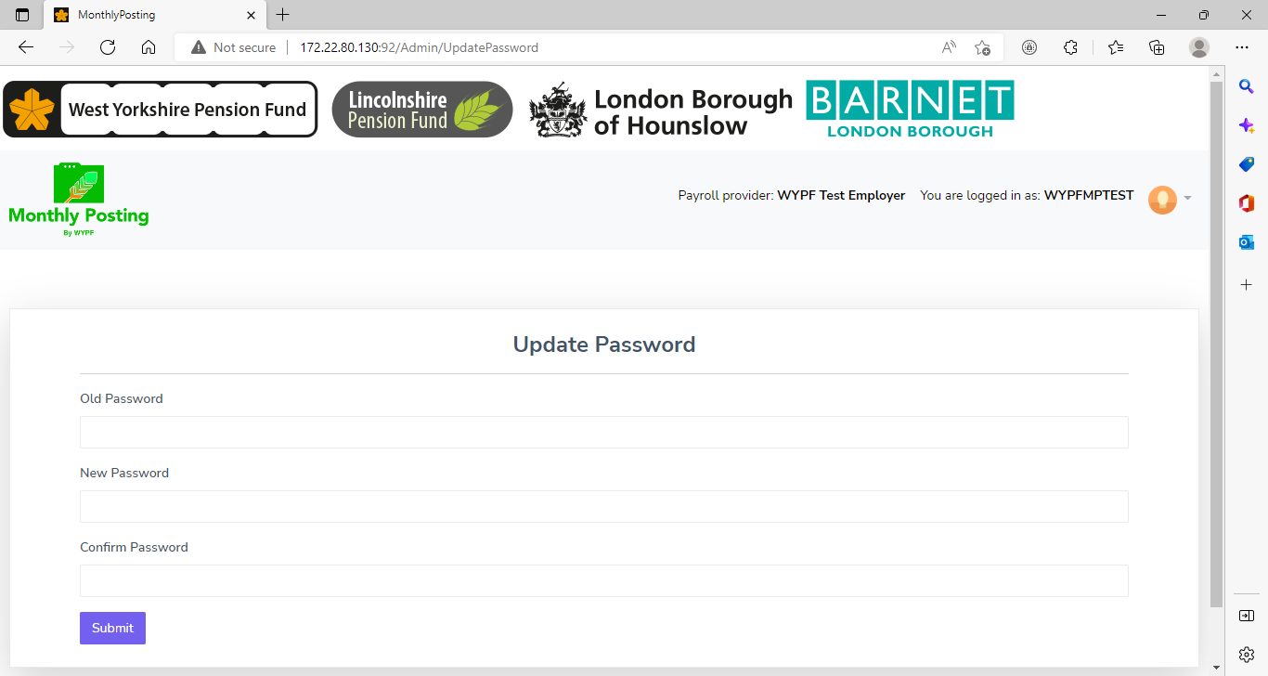

This button will allow you to get back to the home page of the monthly posting portal.

**New Contribution Upload**

This is where you upload your monthly return spreadsheet. The spreadsheet hasn’t changed so you can still use your existing one.

Select the correct pay location (employer) from the drop down list.

If you are submitting one return for multiple employers, it will default to the chosen pay location associated with your login. Please ensure the spreadsheet shows the different location codes and employer names for the separate employers you are submitting the data for.

Select the month and year of the data you are uploading.

Select from 1st posting, 2nd posting or previous month data, which can be used for adjustments to previous months pay.

You can only upload one file per month using 1st posting so there will be times when you will need to select 2nd posting for any adjustments if a secondary return is required or use previous months’ data for any multiple months.

Choose the file you want to upload

Click Validate File

If you have previously uploaded the file and have chosen 1st posting you will receive the following message



Otherwise it should say file uploaded successfully once all validation checks are complete.

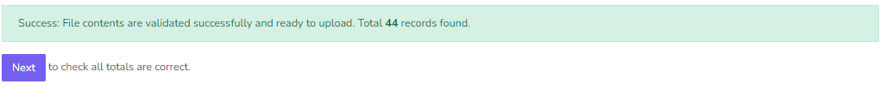

Select Next

The screen will then pre-populate the totals and you will need to check these figures agree with the payment that you are making.

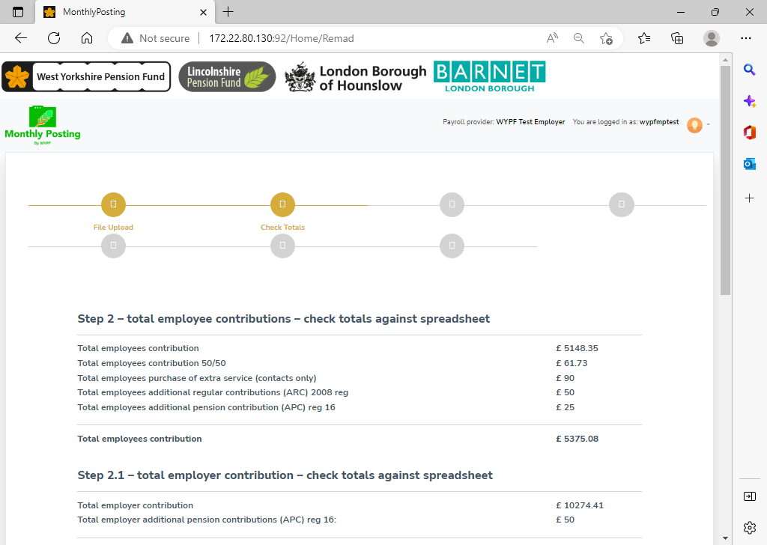

If you have any additional payments, you can enter them in step 3

The validation checks remain the same as before. If you are having problems with the upload of your spreadsheet, please contact your finance business partner.

Check the grand total of all the contributions and additional payments that you are making and add any additional information if necessary.

Finally tell us how and when you will make the payment and click "Send".

1. **TUPE members**

The system will identify any possible tupe cases you may have on your spreadsheet and will alert you by showing the following message after you have uploaded your file and checked the totals.

It will categorise them into potential Tupe In and Tupe Out cases.

You can expand the list to show which members are identifying as possible Tupe’s.

If you believe them to be part of a Tupe then you have the option to select individual members or acknowledge everyone in bulk.

Once you have selected the members you want to identify as tupe cases you will receive a message highlighted in green saying your selection has been acknowledged.

This will then avoid the system wanting to create new folders for the members who are part of a Tupe and therefore the errors or warnings relating to these members will not be generated.

If you select next without expanding the lists, it will take you directly to Step 1 to initialise the database checks.

The system will create errors/warnings for the possible Tupe members which you will have to work though before being able to submit your file.

A message will appear to confirm your file has been uploaded successfully.

You need to select Start now for step 1 to initialise the databse checks

Once this check is completed you can move to step 2 and initialise the matching process by selecting Start now.

The data summary will list the total lines on your return and show how many have been matched at person level and at folder level. Folders are the members individual pension records which relate to each separate job they hold.

You can view the errors and warnings summary from this screen, or you can exit and return to the dashboard later.

The new MC3 portal will allow you to have multiple users working on the error and warnings at the same time from separate logins and if you don’t have the time to complete everything and submit your return, it will save any progress you have made for the next time you log back in.

**Dashboard**



Here you can view your pending, with WYPF and completed files.

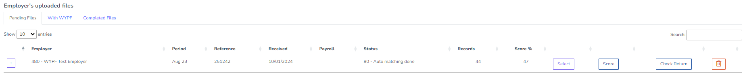

To access the errors and warning please go to your pending files and then press select.

A summary of all the errors and warnings for that return will then be displayed. If you have already attempted to clear some, it will just display those left that require action.

A list of the possible errors and warnings are available. **See** **Appendix. C**

**Please work through the list in default order**

If you have actioned an error or warning incorrectly you have the option to clear your choice and reset to its original position.

If you have cleared your last error or warning in a category which you believe you may have done incorrectly and the category is no longer available, you can contact your finance business partner and they can help you get access to the error or warning.

Errors require you to select where to allocate the pay and contributions by choosing either an existing record or creating a new one.

Example of an error for a person with the same NI number, but not full matching data found at the same employer is below.

**Data taken from our pension database** return

**Data taken from your monthly return**

**Selection screen**

The above error shows the data submitted from your monthly return under Contributions Data Received and the possible matches or the option to create a new record shown under Potential Matches.

The mismatch in this example is the members surname. The monthly submission has Bunny and our UPM database has Rabbit.

You need to decide if the information you have submitted on your monthly return relates to the existing record or choose to create a new record.

This example is showing a change in surname that has not yet been updated on our UPM database. You would select the existing folder you want the information posting to and then submit a Record Maintenance form through the employer portal so our database can be updated. You can do the record maintenance form after you have cleared all your errors and warnings and submitted your return.

Function to Switch View from selection screen to edit screen allows you to access more information provided from the return. The edit screen is explained in detail later.

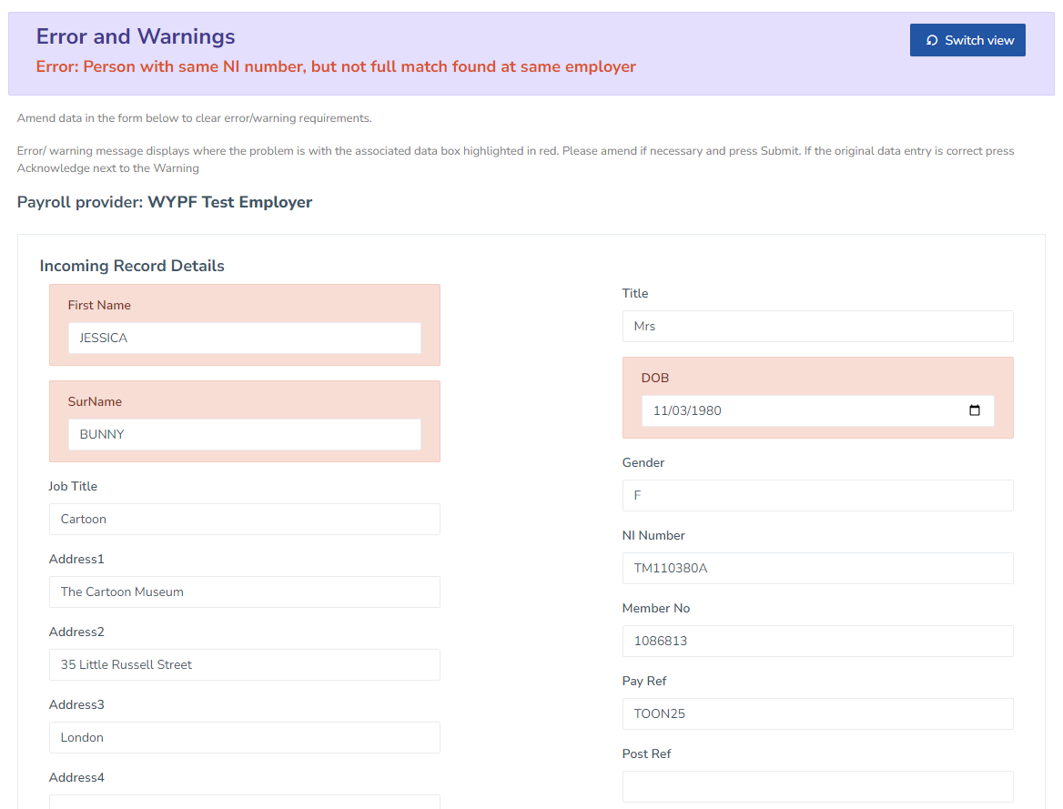

**Edit screen**

If you forget to do the record maintenance form the same error will appear next month.

The matching criteria used is looking at forename, surname, hours, pay ref, date of birth, national insurance number.

Once all the same error type has been cleared you need to select back to get to the list of errors and warnings.

Another example of an error; this time the error is Opt-out flag is missing and Opt-out date is more than 12 months warning.

The Edit screen will allow you to edit the information you have provided on your return.

It lists the errors at the top.

This example is showing an opt out flag is missing. The member will have either left employment or opted out of the scheme. The field that needs editing is highlighted in red.

If the member has opted out you will need to input the opt out flag which will be either contractual or auto depending on how they were first enrolled (shown as enrolment type under date joined). This example is showing AUTO so you would put Auto as the reason for the opt out flag.

Warnings will give you the option of either an edit screen where you can provide the missing information or for you to acknowledge the warning individually or in bulk. This warning needs to be checked if the date of opting out is correct as it’s more than 12 months old.

These warnings are showing a new folder will be created as there are no existing folders at this employer to post the information to.

You can check the individuals details to see what you have put on your return by selecting view and then acknowledge them individually, or If you are happy the list shows all genuine new starters, then you can acknowledge them all in bulk to clear all the warnings simultaneously.

More examples of the possible errors and warnings can be found in**Appendix. C**

Once you have cleared all the errors and warnings you should get the option to check your return. If you are happy the return is ok you can submit your data to WYPF. The file will then appear in the completed files and the status will say submitted to WYPF.

The file will then be picked up by your finance business partner to check and authorise the information to the UPM database.

If you have any issues with clearing your error and warnings or are having trouble completing your submission on time. Please contact your finance business partner who can help.

Once the file has been processed by WYPF then exception reports are generated.

The MC3 portal will allow multiple users to access it simultaneously and it will save any progress people have made for when they log back in, so you can pick up from where you left off.

1. **Exception reports**

When your monthly return has been processed we will send your finance contact an e-mail letting them know that your return is finalised and whether you have any exception reports available to view. These exception reports are held on the **employer portal** which can be accessed under the Online administration area of the employer zone of our website.

Once you have logged-in to the employer portal you will see on the left-hand menu “View Location Details”, click here and choose the pay location of the employer that you want to see the reports for. Click on View Documents, you will then see the exception reports and other documents listed in date order. You can open the exception report by clicking on view document. The report will then open in Excel once you select “click here to open document in the new window”.

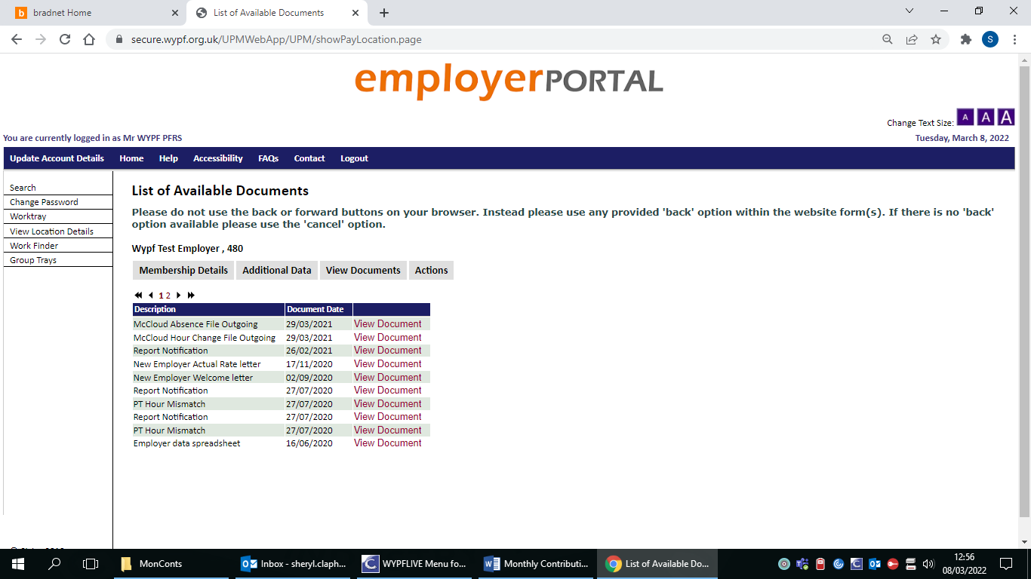

The list of exception reports available are shown below. There are 5 different reports but you may not have all 5 every month.

**PT Hour Mismatch – Action Required**

**This spreadsheet can be returned to us to process any hour changes. See action required below.**

When we have processed your monthly return, we compare the information that you have provided against the information we hold on our system. If we have matched a record but the hours you have provided don’t match our system, a PT Hours Mismatch report will be created.

You should look at each of these errors and provide us with the correct information. You only need to view the most recent PT Hours Mismatch Report as this this a rolling report.

**Action required**

For straight forward hours changes you can just add the date of the change to the spreadsheet and return to us via Galaxkey (our secure data transfer) to [wypfdata@wypf.org.uk](mailto:wypfdata@wypf.org.uk) for processing. You should NOT include notes or change any of the columns on the PT Hours Mismatch spreadsheet. If you need to add notes, please complete the record maintenance web form using the employer portal. You should also complete this for more complicated hour changes.

Hours are represented as decimals, we will record 15 hours and 45 minutes as 15.75.

If you have previously sent us a record maintenance form for a member they will be excluded from the report, so will casual members and those on career breaks. You can find more information about submitting forms in the employer portal manual.

**New starter report – For information purposes only**

**Do not send a copy of this spreadsheet back to us**

We will create a new record for any members which have a date joined scheme on your monthly return. If we can’t match the data to an existing record (which we won’t if it’s a genuine new starter) we will set them up as a new starter. If you are happy with everyone listed on your new starter report you do not need to do anything. If you have members who have been set up in error, please contact your finance business partner or pension fund representative so we can arrange for them to be deleted.

If you find a start date is incorrect then please send an email to [pensions@wypf.org.uk](mailto:pensions@wypf.org.uk) and confirm the correct start date. Please provide the members folder reference number so we can ensure we have corrected the appropriate pension record as some members have more than one.

**Common problems**

Listed below are a few examples that can cause a new record to be created when we don’t require one:

* Change in payroll provider and they insert a date in date joined or date left scheme column
* Promotions/change of job within the same organisation – if the employment is consecutive and the pay has increased, please just amend the payroll number and job title if necessary and provide the information for the month of change on one single line for both posts
* If the member has a change of payroll number or job title part way through the month, do not create an additional line

**Leaver notifications required – Action required**

**Do not send a copy of this spreadsheet back to us**

If you have told us that a member has left the pension scheme or a member no longer appears on your monthly return but we still hold an active record for them, we will notify you that we need a leaver notification completing.

**Action required**

For those members that have left, you should complete a leaver notification. You can do this on the employer portal.

If the member has not left the scheme, please provide us with an email of why they are not on the monthly return. Send your email to [pensions@wypf.org.uk](mailto:pensions@wypf.org.uk)

**Change of Address report – For information purposes only**

**Do not send a copy of this spreadsheet back to us**

This is a list of all the member address updates completed from the data on the Monthly Return.

You don’t need to send us any further information for these members, you only need to check that every update on the list is a genuine change of address and not been completed in error. If you are happy with all of the updates on your change of address report you do not need to do anything.

If you have members who have a change of address completed in error, please contact us so that we can arrange for them to be amended. These need to be corrected as soon as possible to ensure data quality.

If this has occurred failure to notify us may result in a potential data breach.

**Retirement Reconciliation mismatch – Possible Action required**

**Do not send a copy of this spreadsheet back to us**

This report will show a list of retired members where the Cumulative Pensionable Pay (CPP) received on the monthly file differs from the information you have provided to us on the retirement notification.

The report should act as a check list for you to work through and provide us with any necessary additional pay forms to instruct us to re calculate the members retirement benefits using the correct Cumulative Pensionable Pay (CPP).

If there is already a recalculation on the record, we won't include these members on the mismatch report.

The report will only show mismatches that have been identified that month, they will not reappear over to the next months report, therefore it is important that you review the retirement reconciliation report every month to ensure that you are sending us the necessary additional pay forms.

**Limitations to the Retirement Reconciliation Report**

Cases where we process the retirement late, for example the retirement notification is received months after retirement or if member sends claim form late and all postings are received, if there is a discrepancy between monthly postings and retirement notification

Pay received in the next financial year, for example back dated pay awards

For these types of cases, where a recalculation applies, you will need to send us an additional pay form however they won’t appear on the mismatch report.

**Action required**

We need you to give us an instruction to recalculate the retirement benefits based on the correct CPP by completing an additional pay form via the employer portal. You must ensure that the CPP matches what

you have provided on the monthly return.

1. **Process mover**

This function which is used to move the blocks and quarantine processes created after posting the March return is now available on the Dashboard.

**Process Mover**

For further information on how to use the UPM process mover and complete your blocks and quarantine queries please refer to the Worktray manual – Pension statements [here](https://www.wypf.org.uk/lgps-employer-zone/forms-and-guides/)

1. **Cumulative Pensionable Pay (CPP)**

Cumulative Pensionable Pay (CPP) and/or Assumed Pensionable Pay (APP) are the total amount of “pensionable pay” in either section of the scheme in the scheme year.

This includes the value of payments specified in the contract of employment as being pensionable (including the pensionable value of salary sacrificed for such items as child care vouchers, and for pension contribution salary sacrifice via a shared cost AVC arrangement).

The cumulative pensionable pay must be provided separately for each section as different accrual rates will apply when calculating the pension in each section. If the member moves between sections more than once in a scheme year there is no requirement to differentiate between different periods in the same sections (although the dates the member was in each section need to be provided).

The cumulative amounts should contain all of the CPP and/or APP in each section during the year.

**Example**

A member on a salary of £24,000 throughout the full scheme year opts for the 50/50 section 3 months into the scheme year, at which point they have already earned **£6,000**.

The member spends 6 months in the 50/50 section accruing **£12,000**,and then opts back into the main scheme for the final three months of the year accruing a further **£6,000**.

The cumulative totals at the end of the scheme year are: main scheme **£12,000** and 50/50 section **£12,000.**

1. **Assumed Pensionable Pay (APP)**

This replaces “notional pay” in cases of reduced contractual pay or nil pay as a result of sickness or injury; or during relevant child related leave (i.e. ordinary maternity, paternity or adoption leave and any paid additional maternity, paternity or adoption leave); or whilst on reserve forces service leave.

In this situation (and only in this situation) the amount added to the CPP should be the APP and not any pensionable pay received, unless the pensionable pay received for any given day in that period is greater than the APP (e.g. pay from KIT day(s) or Stringer day(s)), in which case pensionable pay is added to CPP for that day and APP is added for the other days.

**Calculation**

APP is calculated as an annual rate then added to the relevant period as a proportion of that rate. The annual rate of APP is calculated as follows:

**Pay periods not monthly**

Calculate the average of the pensionable pay for the 12 complete weeks before the relevant event after taking off any pensionable lump sum payments, but including any APP previously used in those pay periods and gross up to an annual figure. If 12 complete weeks’ pay does not exist use as many complete periods as available.

The relevant event is the date the employee drops to reduced **contractual** pay or nil pay due to sickness or injury, or during relevant child related leave (i.e. ordinary maternity, paternity or adoption leave and any paid additional maternity, paternity or adoption leave), or the date the member started reserve forces service leave.

Note: APP does NOT accrue during any period of unpaid additional maternity; paternity or adoption leave available at the end of relevant child related leave; this is to be treated as unpaid leave of absence.

**Monthly paid**

For a monthly paid employee three complete pay periods should be used instead of 12 weeks but the calculation is the same.

1. **Appendix. A**

**West Yorkshire Pension Fund Employers**

You can pay direct to West Yorkshire Pension Fund bank account:

HSBC

Park Street Branch

PO Box 125

2nd Floor, 62-76 Park Street

London

SE1 9DZ

Account number **91383728**

Sort code **40-02-50**

Account name **West Yorkshire Pension Fund**

If you can’t pay by BACS transfer, please contact our finance department on 01274 434563 to discuss an alternative method of payment.

**Lincolnshire Pension Fund Employers**

You can pay direct to Lincolnshire Pension Fund bank account:

Barclays Bank PLC

316-318 High Street

Lincoln

LN5 7DP

Account number **93781607**

Sort code **20-50-39**

Account name **Lincolnshire County Council – Pension Fund Account**

IBAN                        GB66 BARC 2050 3993 7816 07

SWIFT CODE          BARCGB22

If you can’t pay direct into Lincolnshire Pension Fund’s bank account please send your cheques, made payable to Lincolnshire Pension Fund to:

Lincolnshire County Council

Pension Fund

County Offices

Newland

Lincoln

LN1 1YL

**London Borough of Hounslow Pension Fund Employers**

You can pay direct to the Hounslow Pension Fund bank account:

**NatWest Bank**

**275 – 277 High Street**

**Hounslow**

**TW3 1ZA**

Account number: **20364733**

Sort code: **60-11-18**

Account name: **London Borough of Hounslow Pension Fund**

**London Borough of Barnet Pension Fund Employers**

You can pay direct to the Barnet Pension Fund bank account:

**NatWest Bank**

Account number: **69433666**

Sort code: **60-15-20**

Account name: **London Borough of Barnet Pension Fund**

1. **Appendix. B**

**Definition of Pensionable Pay 2013 Regulations**

**Important:** This definition should be used for the purposes of determining deductions to pensionable pay from April 2014 onwards and recording actual pensionable pay on leaver forms and monthly contribution returns **NOT** for calculating Pension Remuneration figures (Pension Remuneration figures should be calculated using the 2008 definition further down this page)

**An employee’s pensionable pay is the total of:**

* all the salary, wages, fees and other payments paid to the employee, and
* any benefit specified in the employee's contract of employment as being a pensionable emolument

**But an employee’s pensionable pay does not include:**

* any sum which has not had income tax liability determined on it;
* any travelling, subsistence or other allowance paid in respect of expenses incurred in relation to the employment;
* any payment in consideration of loss of holidays;
* any payment in lieu of notice to terminate a contract of employment;
* any payment as an inducement not to terminate employment before the payment is made;
* any amount treated as the money value to the employee of the provision of a motor vehicle or any amount paid in lieu of such provision;
* any payment in consideration of loss of future pensionable payments or benefits;
* any award of compensation (excluding any sum representing arrears of pay) for the purpose of achieving equal pay in relation to other employees;
* any payment made by the Scheme employer to a member on reserve forces service leave;
* returning officer, or acting returning officer fees other than fees paid in respect of—
  + local government elections,
  + elections for the National Assembly for Wales,
  + Parliamentary elections, or
  + European Parliamentary elections.

**Important:**When providing pensionable pay figures on any forms, these should always cover the period the payments relate to rather than the dates that the payments were actually made.

**Definition of Pensionable Pay 2008 Regulations**

**Important:** This definition should be used for the purpose of calculating Pension Remuneration figures, as required for all members with pre-April 2014 service

Under the LGPS Benefits, Contributions and Membership Regulations 2007 the definition of pensionable pay is given in the excerpts below:

**An employee’s pensionable pay is the total of:**

* all the salary, wages, fees and other payments paid to him for his own use in respect of his employment; and
* any other payment or benefit specified in his contract of employment as being a pensionable emolument.

**But an employee’s pensionable pay does not include:**

* payments for non-contractual overtime;
* any travelling, subsistence or other allowance paid in respect of expenses incurred in relation to the employment;
* any payment in consideration of loss of holidays;
* any payment in lieu of notice to terminate his contract of employment; or
* any payment as an inducement not to terminate his employment before the payment is made.
* the amount of any supplement paid -
  + by the Environment Agency
  + to an employee in recognition of the difference in contribution rates between, members of the Principal Civil Service Pension Scheme, and the LGPS. These would be would be members that have transferred on 1st April 2010, under a staff transfer scheme, from the Learning and Skills Council for England to either a local authority or London Council Limited.
* any award of compensation (excluding any sum representing arrears of pay) for the purpose of achieving equal pay in relation to other employees.

No sum may be taken into account in calculating pensionable pay unless income tax liability has been determined on it.

**Important:**When providing pensionable pay figures on any forms, these should always cover the period the payments relate to rather than the dates that the payments were actually made.

1. **Appendix. C**

**Trouble shooting errors and warnings**

**Errors**

**Person with same NI number but not full match found at same employer**

Action required – check the mismatching data and either amend your data or inform WYPF of the correct data using the Record Maintenance form. Then choose to allocate contributions to existing folder or select new folder where appropriate and click submit

**Person with different NI number but with other matches found at same employer**

Action required – check the mismatching data and either amend your data or inform WYPF of the correct data using the Record Maintenance form. Then choose to allocate contributions to existing folder or select new folder where appropriate and click submit

**More than one folder matches to this contribution record**

Action required - check the mismatching data and either amend your data or inform WYPF of the correct data using the Record Maintenance form. Then choose to allocate contributions to existing folder or select new folder where appropriate and click submit

**You may find members have multiple records which will require you to select which folder the contributions belong to. Inform WYPF if any rogue records are displaying.**

**Multiple contribution records in this return matched to this folder**

Action required - check the mismatching data and either amend your data or inform WYPF of the correct data using the Record Maintenance form. Then choose to allocate contributions to existing folder or select new folder where appropriate and click submit

**Both leaving date and opt out date are present – must be one or the other!**

Action required – View the full details and either delete the leaving date or opt out date (including enrolment type) and click submit

**The member has either left the job or opted out of the pension scheme**

**Leaving date is before join in date**

Action required – View the full details and Insert correct date left scheme/employment in date opt-out date or date left box

**Opt out type must be set if opt out date is present & Opt out flag missing**

Action required – View the full details and Insert contractual or auto enrolment in enrolment type box and click submit

**New folder, there are existing folders at this employer**

Action required - check the mismatching data and either amend your data or inform WYPF of the correct data using the Record Maintenance form. Then choose to allocate contributions to existing folder or select new folder where appropriate and click submit

**Date joined scheme is blank**

Action required – View the full details and Insert date joined scheme in date joined box and click submit

**Enrolment type blank**

Action required – View the full details and Insert contractual or auto enrolment in enrolment type box and click submit

**Warnings**

**New person and folder will be created**

Action required – View the full details and click submit if new record needs creating

**You have the option to bulk authorise the creation of new folders by selecting Acknowledge ALL**

**New folder start date out of range**

Action required – View the full details and correct the start date and click submit or acknowledge the start date is correct

**Opt out date is more than twelve months’ old**

Action required – View the full details and correct the opt out date and click submit or acknowledge the opt out date is correct

**New folder, no existing folders at this employer**

Action required – View the full details and click submit if new record needs creating

**You have the option to bulk authorise the creation of new folders by selecting Acknowledge ALL You can also amend any incorrect information at this stage by selecting view and changing the data here**

Examples:

**Person with same NI number but not full match found at same employer (2 examples)**

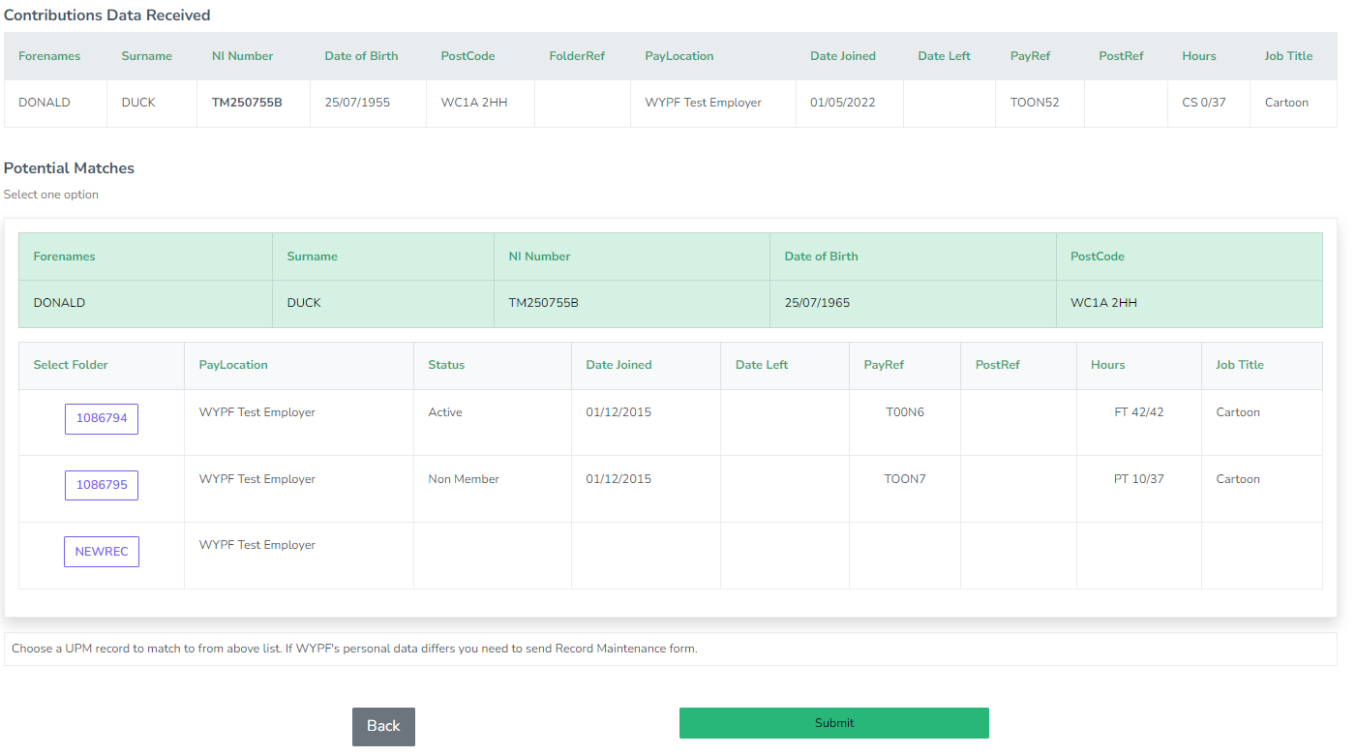

This is showing a mismatch with the date of birth. If the information is incorrect on your return update your payroll system or if we are showing the wrong information submit a record maintenance form. Select the correct folder you wish to allocate the pay and contributions or choose to set up a new record.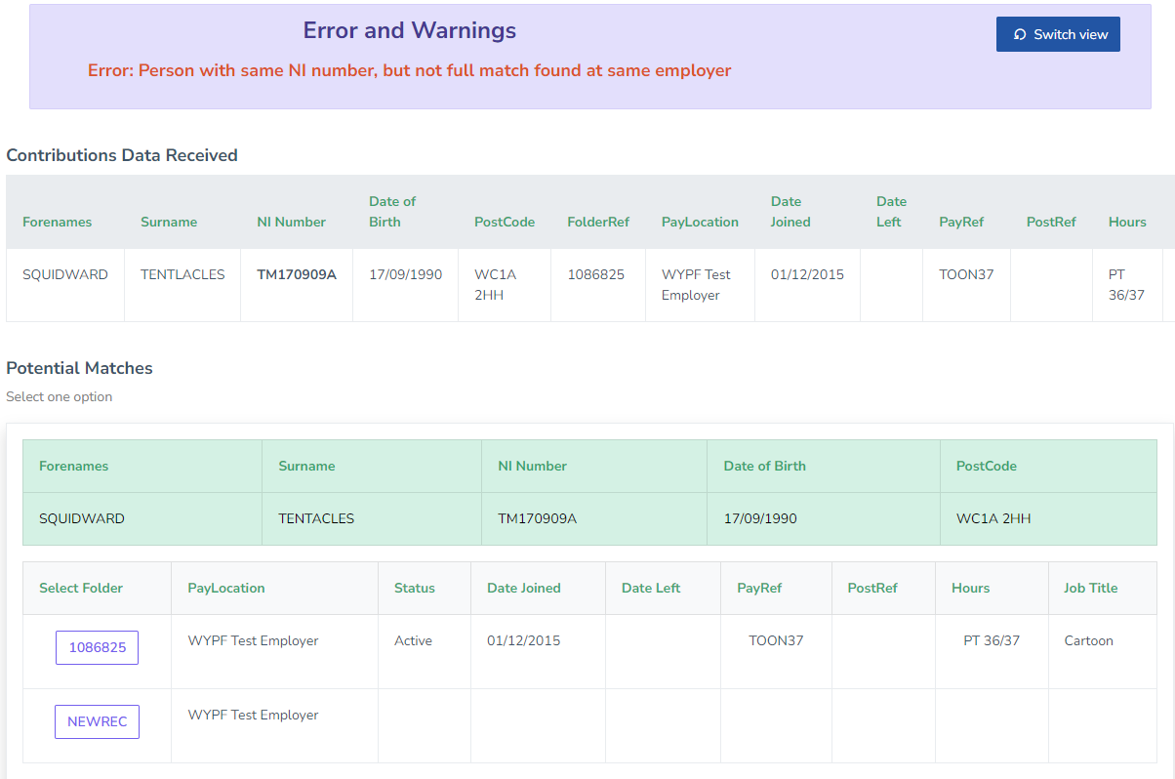

This is showing a mismatch with the surname. If the information is incorrect on your return update your payroll system or if we are showing the wrong information submit a record maintenance form. Select the correct folder you wish to allocate the pay and contributions or choose to set up a new record.

**Person with different NI number but with other matches found at same employer (1 example)**

This is showing a mismatch with the National Insurance number. If the information is incorrect on your return update your payroll system or if we are showing the wrong information submit a record maintenance form.

Select the correct folder you wish to allocate the pay and contributions or choose to set up a new record.

**New folder, there are existing folders at this employer (1 example)**

This is showing a mismatch with the pay reference number and hours. This can be due to a job change or just an increase or decrease in the contracted hours.

If the information is incorrect on your return update your payroll system. If we are showing the wrong information submit a record maintenance form to tell us of the new payroll number/hours/job title.

Select the folder you wish to allocate the pay and contributions or choose to set up a new record. If this is treated as a continuation of the original record you will receive a part time hour mismatch report, which you can use to notify us of the date of the hour change.

**More than one folder matches to this contribution record (1 example)**

This example can happen when records have been set up in error from previous postings.

If you believe a record has been created in error please send an email to your pension fund representative, finance business partner or to [wypf.pfr@wypf.org.uk](mailto:wypf.pfr@wypf.org.uk) and give us the folder numbers of the records and which postings you want moving to and from.

**Multiple contribution records in this return matched to this folder (1 example)**

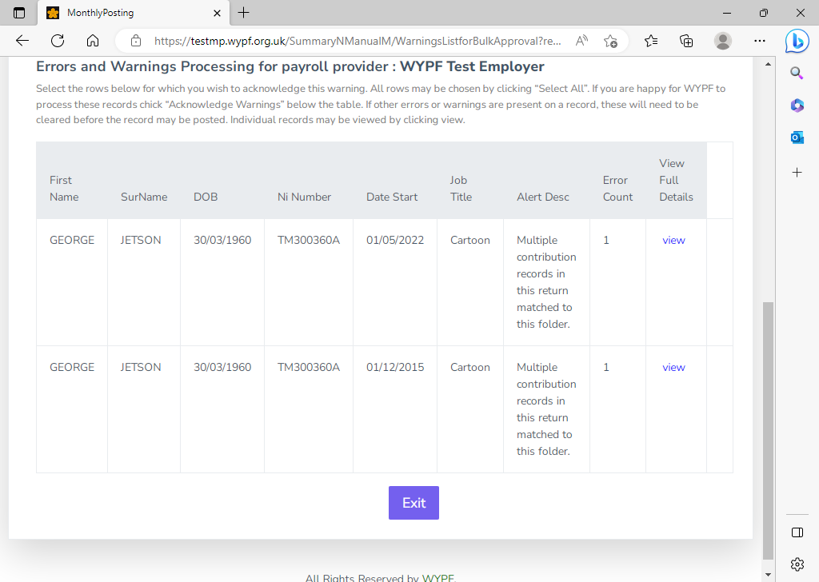

This error is due to you having more than one line on the monthly return matching to a single folder.

View both errors and decide which line belongs to the existing record and which one is either a continuation of the existing record or is needing a new record creating.

**Date joined scheme is blank & Enrolment type is blank (1 example)**

View the error to get the full details. Mighty Mouse has 1 warning and 2 errors. As there is no person or folder for this member a new person and folder will need creating.

To do this we need a date joined scheme and the enrolment type.

Give the date the member joined the scheme and choose if it was through contractual employment or auto enrolment. Click submit.

You will then be able to acknowledge the creation of the new folder once you get to the New person and folder will be created warning.

**Both leaving date and opt out date are present – must be one or the other!**

**And** **Opt out type must be set if opt out date is present (1 example)**

View the error to get the full details. Scooby Doo has 2 errors. The return is showing dates in both the date left and opt out date fields.

The member has either left employment (date left) or opted out of the pension scheme (opt out). They will not have done both. The other error is because if the member has opted out, we also need an opt out type.

To clear these errors, you need to decide if this member has left employment or opted out of the pension scheme. If they have left, remove the opt out date. If they have opted out, remove the date left and input AUTO in the opt out flag.

**Opt out date is before join date**. **Opt out date is more than twelve months’ old. Opt out flag missing (1 example)**

View the error to get the full details. Judy Jetson is showing 2 errors and 1 warning.

This could be due to an old opt out date still showing on the monthly submission.

To fix the errors and warning you would remove the opt out date. This one action will then clear both error and warning.

**New person and folder will be created (2 examples)**

This warning is informing you we have no person or folders that match your data for Speedy Gonzales or Mighty Mouse.

Your only option will be to create a new person and folder for each of them. If you are happy they are two new starters, then you can select the Acknowledge All button and this will clear the warnings and set up two new records.

You can view the full details for each person to check you are happy with the information you have submitted which will also give you the option to amend information if necessary.

**New folder start date out of range (1 example)**

This warning has appeared because the date joined is showing as 01/12/2015. This could be an error with the payroll information being pulled across and is still picking up the original start date for a new post.

To clear the warning, you can either acknowledge the start date is correct, and a new record will be created or view the details and amend the date joined to show the correct date of joining the scheme in the new post.

**New folder, no existing folders at this employer (5 examples)**

This warning is informing you we have no existing folders for you that match your data on your submission.

If you are happy that all five relate to new jobs and need a record creating, you can use the acknowledge all button to do this in bulk or alternatively select view to check the details you have supplied are correct, amend if necessary and submit on an individual basis.

1. **Contact Information**

**Employer Pension Fund Representatives**

To find out who is your Employer Pension Fund representative or Finance Business Partner, go to the Employer Portal and select the following:

* + View Location Details
  + Pay Location
  + Membership Details Screen

**Employer help –** [**wypf.pfr@wypf.org.uk**](mailto:wypf.pfr@wypf.org.uk) **01274 434900**

|  |  |  |  |
| --- | --- | --- | --- |
| **FUND** | **PFR** | **EMAIL** | **PHONE** |
| West Yorkshire | Sheryl Clapham | [Sheryl.Clapham@wypf.org.uk](mailto:Sheryl.Clapham@wypf.org.uk) | 01274 432541 |
| Lincolnshire | Kaele Pilcher | [Kaele.Pilcher@wypf.org.uk](mailto:Kaele.pilcher@wypf.org.uk) | 01274 432739 |
| Hounslow & Lincolnshire | Finola Middleton | [Finola.Middleton@wypf.org.uk](mailto:Finola.Middleton@wypf.org.uk) | 01274 432726 |
| Barnet | Richard Quinn | [Richard.Quinn@wypf.org.uk](mailto:Richard.Quinn@wypf.org.uk) | 01274 433646 |
| All Funds Admitted Bodies | Ahmed Surtee | [Ahmed.Surtee@wypf.org.uk](mailto:Ahmed.surtee@wypf.org.uk) | 01274 433517 |
| Fire Authorities | David Parrington | [David.Parrington@wypf.org.uk](mailto:David.Parrington@wypf.org.uk) | 01274 433840 |
| West Yorkshire | Mark Morris | [Mark.Morris@wypf.org.uk](mailto:Mark.Morris@wypf.org.uk) | 07484 918008 |

**Finance Business Partners**

Direct contact with the FBP is preferred however if you can’t get hold of them, please use this mailbox.

[WYPF.Contributions@wypf.org.uk](mailto:WYPF.Contributions@wypf.org.uk)

**Finance Business Partners**

|  |  |  |
| --- | --- | --- |
| **FBP** | **EMAIL** | **PHONE** |
| Abid Yaqoob | [abid.yaqoob@wypf.org.uk](mailto:abid.yaqoob@wypf.org.uk) | 07812 490730 |
| Abu Sufian | [abu.sufian@wypf.org.uk](mailto:abu.sufian@wypf.org.uk) | 07977 590597 |
| Adam Waddington | [adam.waddington@wypf.org.uk](mailto:adam.waddington@wypf.org.uk) | 07811 503882 |
| Annette Appleyard | [annette.appleyard@wypf.org.uk](mailto:annette.appleyard@wypf.org.uk) | 07812 490017 |
| Charlie Malcom | [Charlie.Malcolm@wypf.org.uk](mailto:Charlie.Malcolm@wypf.org.uk) | 07811 503976 |
| David Baff | [David.Baff@wypf.org.uk](mailto:David.Baff@wypf.org.uk) | 07977 590468 |
| Jummaul Rahman | [Jummaul.Rahman@wypf.org.uk](mailto:Jummaul.Rahman@wypf.org.uk) | 07977 590467 |
| Katarina Zuzova | [Katarina.Zuzova@wypf.org.uk](mailto:Katarina.Zuzova@wypf.org.uk) | 07977 590618 |
| Kayleigh Smith | [Kayleigh.Smith@wypf.org.uk](mailto:Kayleigh.Smith@wypf.org.uk) | 07974 894435 |
| Lois Hunter | [loishunter@wypf.org.uk](mailto:loishunter@wypf.org.uk) | 07811 505686 |
| Richard Clarke | [richard.clarke@wypf.org.uk](mailto:richard.clarke@wypf.org.uk) | 07812 490720 |
| Adam Khan | adam.khan3@wypf.org.uk | 07484 499934 |
| Shaun Parkin | [shaun.parkin@wypf.org.uk](mailto:shaun.parkin@wypf.org.uk) | 07812 490723 |
| Usmaan Maroof | [usmaan.maroof@wypf.org.uk](mailto:usmaan.maroof@wypf.org.uk) | 07977 590659 |
| Zeina Hussein | [zeina.hussein@wypf.org.uk](mailto:zeina.hussein@wypf.org.uk) | 07929 747513 |