

Worktray Manual

Pension Statements

**What happens after the March monthly return has been submitted?**

After we have processed your March return and matched the rows of data to individual pension records, we produce a member’s pension statement.

Before running the pension statement process, we apply some checks to the data we’ve received during the last scheme year (1 April to 31 March).

We look at each pension record that shows a member being active as at 31st March. This will include everyone from your March return as well as people who’ve left your organisation, but we’ve not yet received a leaver notification.

We sort each pension record into one of three categories:

1. **OK** – the data has passed all our checks, and a pension statement will be produced.
2. **Pension Statement Block** – something is missing that will prevent a pension statement being produced. Until we receive the missing information, that member won’t get a statement.
3. **Pension Statement Quarantine** – although we’ve got sufficient data to produce a statement, we would like you to review it. The data *could* be correct: but we’d like you to check it before we produce the statement. However, if we don’t receive a reply within 6 weeks of us starting the quarantine process, we will produce the pension statement using the data we already have.

Where a pension record is categorised as either a Pension Statement Block or Pension Statement Quarantine, we will launch a query process, through which you’ll be able to either provide revised information or confirm what you’ve already supplied is correct.

If a member has multiple jobs within your organisation, it is possible they may have more than one query, as each query relates to a particular job. Your monthly return should show a line of data for each job the member holds within your organisation.

Information Sheet

**What is a Pension Statement –** a document produced every year for each active member of the scheme. It gives a value of benefits at the end of each scheme year and an estimated forecast at different retirement ages.

**What is a Pension Statement Block** – something is missing that will prevent us being able to produce a pension statement. Until we receive the missing information, that member won’t get a statement.

**Which checks result in a Pension Statement Block?**

|  |  |
| --- | --- |
| **Test** | **Description** |
| No pay received | This check only triggers where the members working pattern is either full-time or part-time, so under normal circumstances we would expect the member to have received *some* pay during the year |
| Final Pay looks low | The pay quoted on the March return is less than £10,000, which is roughly the full-time equivalent pay for someone working term-time. Reasons for this triggering could be an apprentice. *(Check only applied to pension records having membership in the scheme before 1.4.2014.)* |
| Final Pay multiple values received | Two or more individual rows on your March return have been matched to the same pension record, each had an entry for Final Pay, but we can’t be sure which record it relates to. *(Check only applied to pension records having membership in the scheme before 1.4.2014.)* |
| Final Pay missing | We are unable to calculate the pension statement without the Final Pay. Reasons for this could be someone in your employment who started after 1.4.2014 – so you don’t think you need to give us Final Pay as it doesn’t apply to that individual – but the member has actually linked or transferred previous Pre 2014 LGPS membership into their current pension record. *(Check only applied to folders having membership in the scheme before 1.4.2014.)* |

**What is a Pension Statement Quarantine -** although we have sufficient data to produce a statement, we would like you to review it before the statement is produced. The data *could* be correct: but we’d like you to review it before we produce the statement. However, if we don’t receive a reply within 6 weeks from the launch date we will produce the pension statement using the data we already have.

**Which checks result in a Pension Statement Quarantine?**

|  |  |
| --- | --- |
| **Test** | **Description** |
| CPP missing (shows the missing month(s) – but March is present | Looking over the last year, we don’t have a monthly entry for each month that the member was in the scheme, but they did appear on the March return. Reasons for this could be a period of unpaid leave, or an issue with payroll where the employee missed a month but then got paid arrears the subsequent month. (Check only applied to full-time or part-time records) |
| CPP fall  CPP jump | Comparing month-on-month, the Main Section pay (CPP) fell or jumped by at least 90%. Reasons could be a promotion or overtime worked. (Check only applied to full-time or part-time records) |
| Suspect leaver – shows month of last CPP received | This member’s pension record didn’t appear on the March return. (Check only applied to full-time or part-time pension records) |
| No data received at all | This check only triggers where the member **doesn’t** work full-time or part-time. Reasons for this could be a casual worker who hasn’t done any work during the year |
| Final Pay increase above tolerance (shows previous year) | *(Check only applied to pension records having membership in the scheme before 1.4.2014.)* |
| Final Pay decrease below tolerance (shows previous year) | *(Check only applied to pension records having membership in the scheme before 1.4.2014.)* |

**Accessing your worktray**

Log on to the Employer Portal through our website

Within the Employer Portal, you will see worktray menu options:

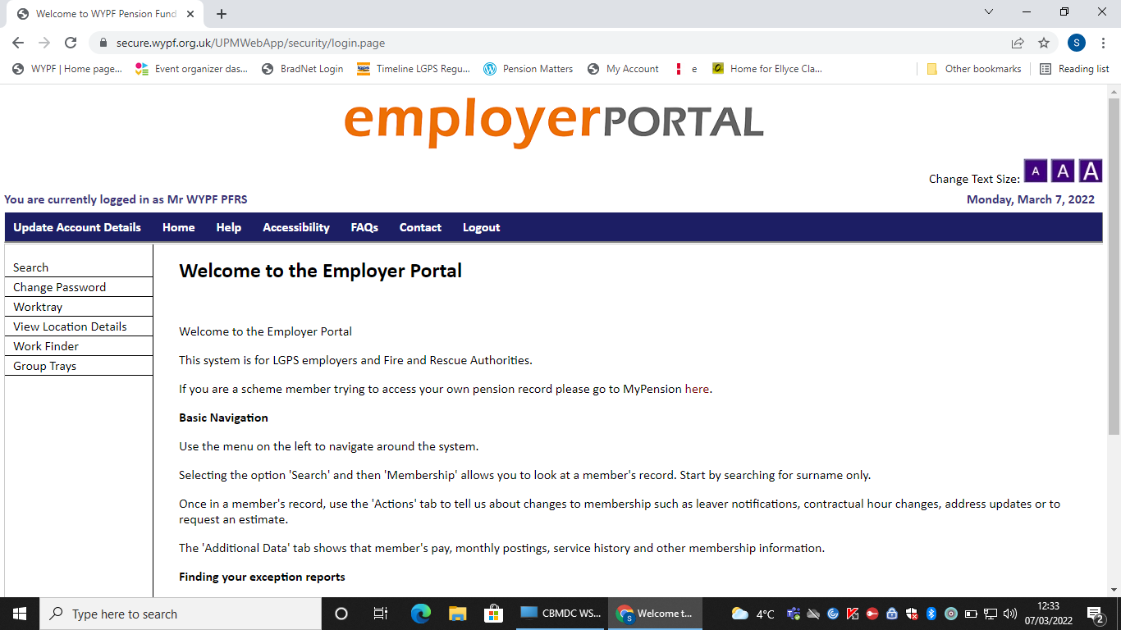

* **Group Trays** – this is where the queries for your organisation (or group of organisations) will initially land.
* **Worktray** – this is your personal work tray. To be able to look at a query and provide a response, you must first move it from the Group Tray into your Worktray
* **Work Finder** – currently under development

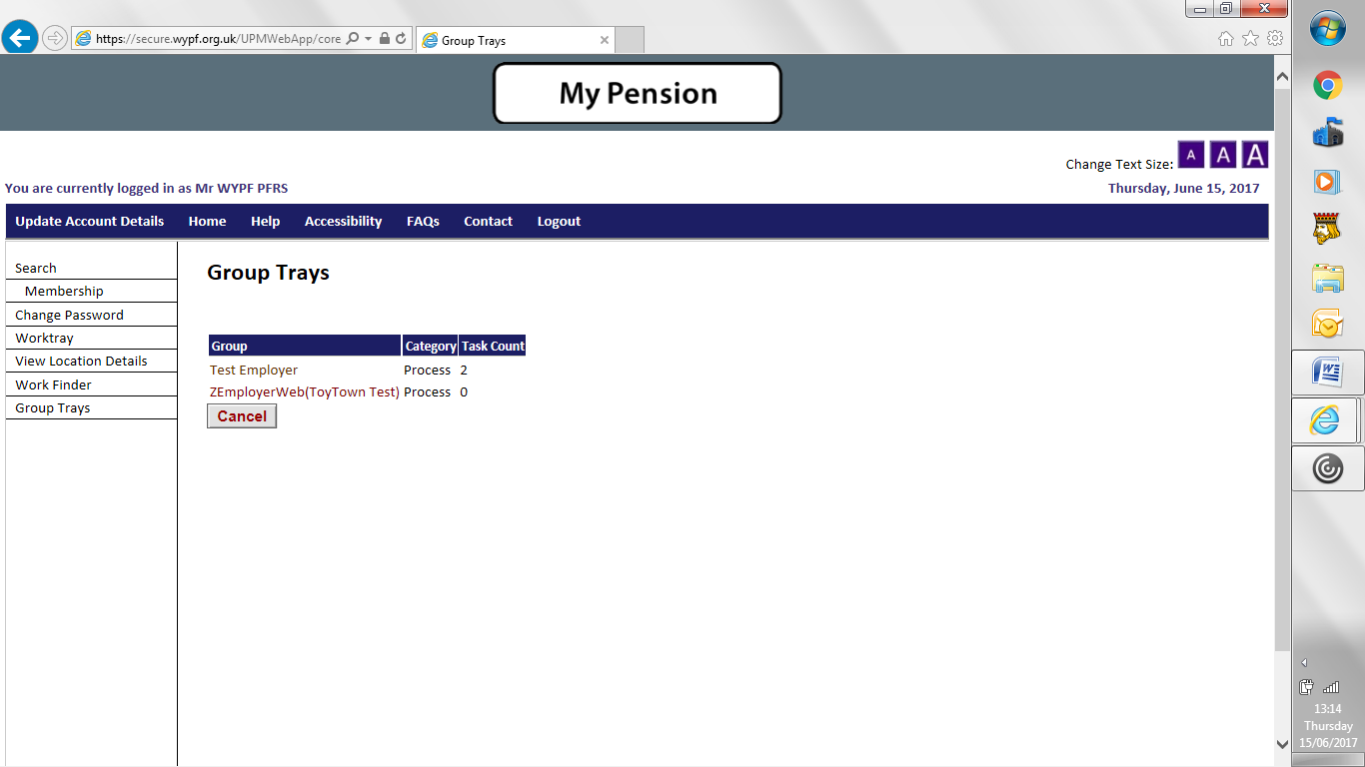

This shows the name of your employer group, along with how many queries are currently in the Group Trays. Click the name of the employer to look inside the Group Trays.

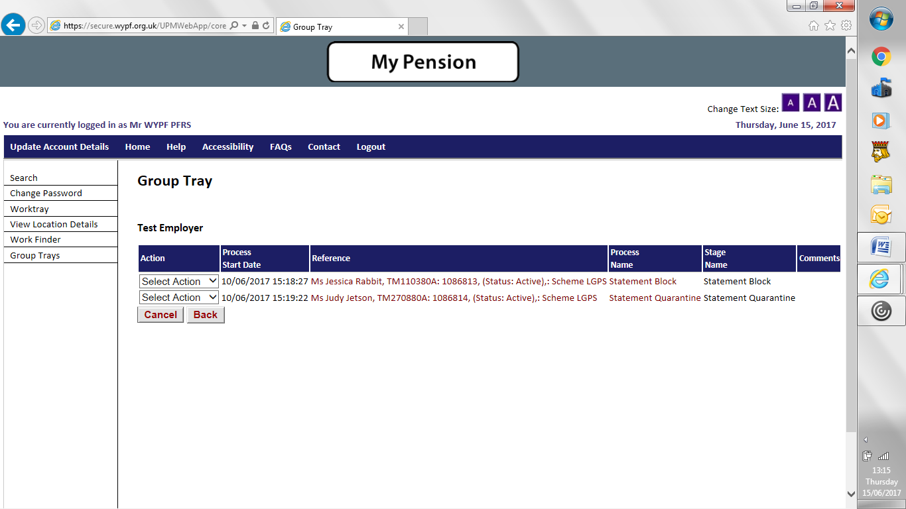

* Process Name: this will show either Statement Block or Statement Quarantine
* Use the fast-forward / rewind buttons or click on the page numbers to move from page to page.

**The Golden Rule of Group Trays**

**You must move a process to your Worktray before you can work on it – or even look at it. You can’t do anything within Group Trays apart from move work out of it.**

How to move an item to your Worktray

1. Click “Select Action” next to the member you want to move
2. Choose “Reassign”
3. Choose your name from the “User” menu. You will see everyone in your organisation here who has an account. You could pick someone else’s name here, to give *them* the work item, instead of yourself.

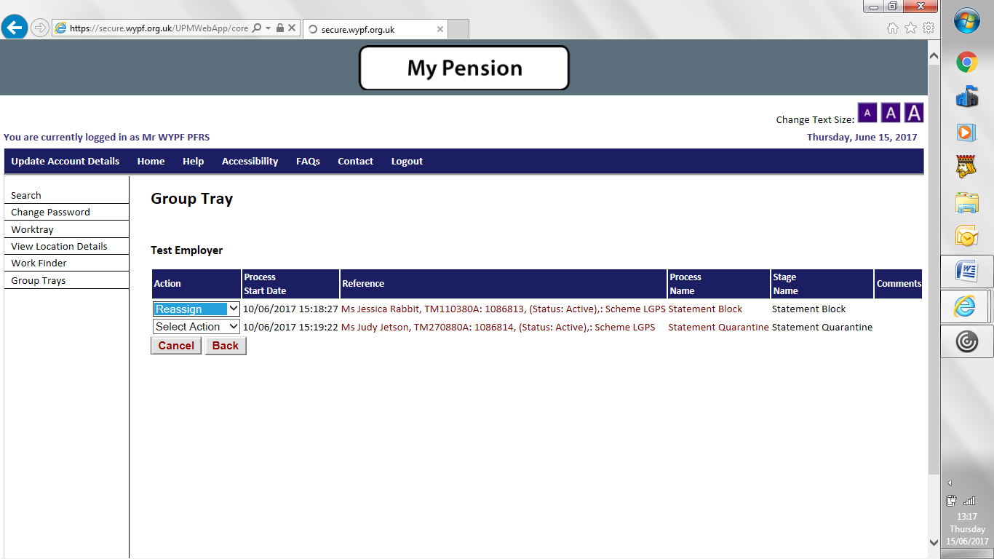

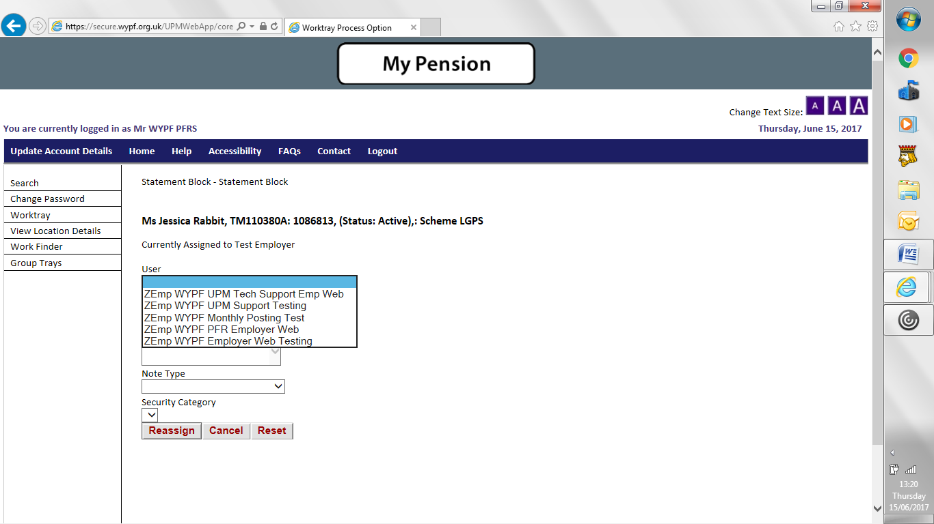

1. Click Reassign

The work item will then be moved from the Group Trays to your Worktray (or whoever’s tray you chose in this step).

**Process mover (alternative to reassigning individual processes)**

To access the UPM process mover you need to login to the **monthly return portal MC3**

This has the same username as the Employer Portal, but you may have a different password.

If you haven’t yet activated your account to the MC3 Portal contact your Pension Fund Representative or Finance Business Partner to receive an activation email.

Once in the portal select Dashboard and then Process Mover

**Process Mover**

This function shows you where the processes are located; either in the group tray or in an individual’s work tray. It will also identify the process, block or quarantine.

To reallocate a process, click on the ProcessNo box, which will then become RED. You can select all processes or a selection (if sharing these out amongst users) then select a user you wish you to allocate the processes by using the drop-down box at the bottom of the screen.

Once you have selected the processes you wish to move you need to choose a user from the list and click Allocate

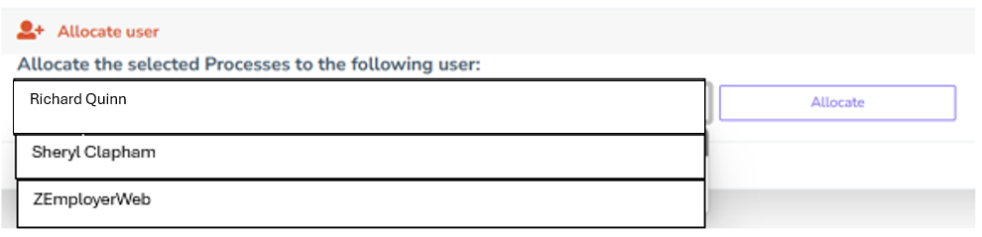

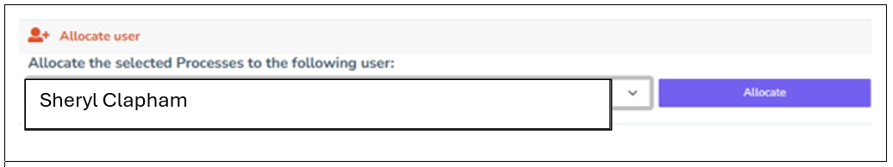

You will receive a message to say it has been successful and the process will then show under the new allocated user or the group tray if the employer has been selected.

**Worktray and working through a query**

Click “Worktray” to view the item(s) currently in your Worktray.

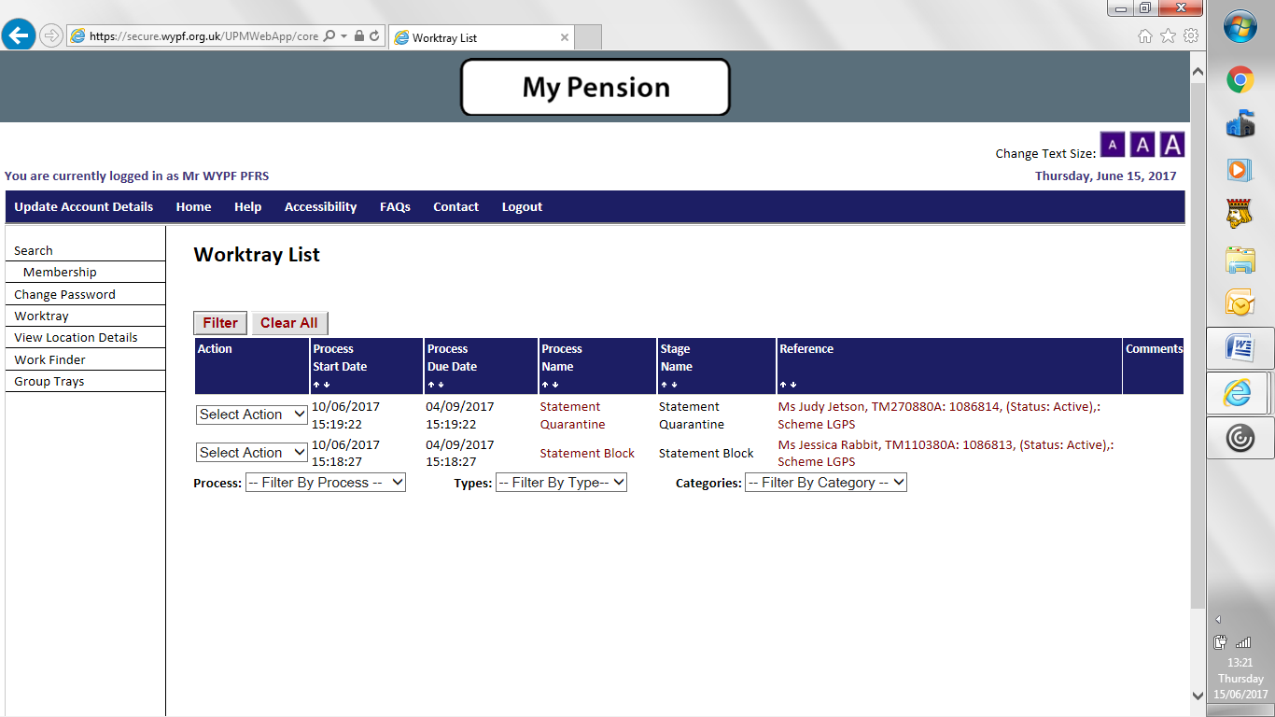

How to **open a query** and provide an answer. There are 2 ways, either:

1. Just click the person’s name, under the reference tab
2. Click Select Action > Open Process

Once either of the above actions have been performed a form will be displayed for you to either submit revised information, tell us the member has left that job or confirm the information we have is correct.

**An example of a Pension Statement Block**

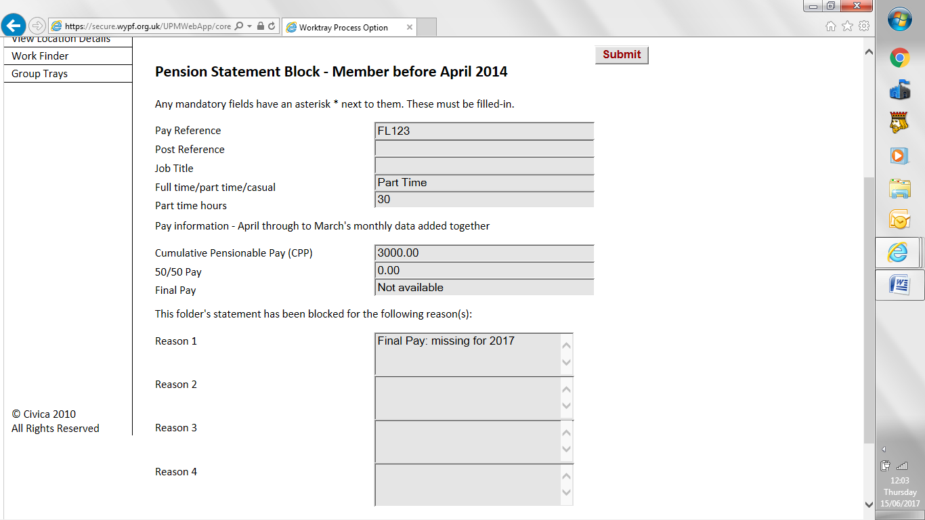

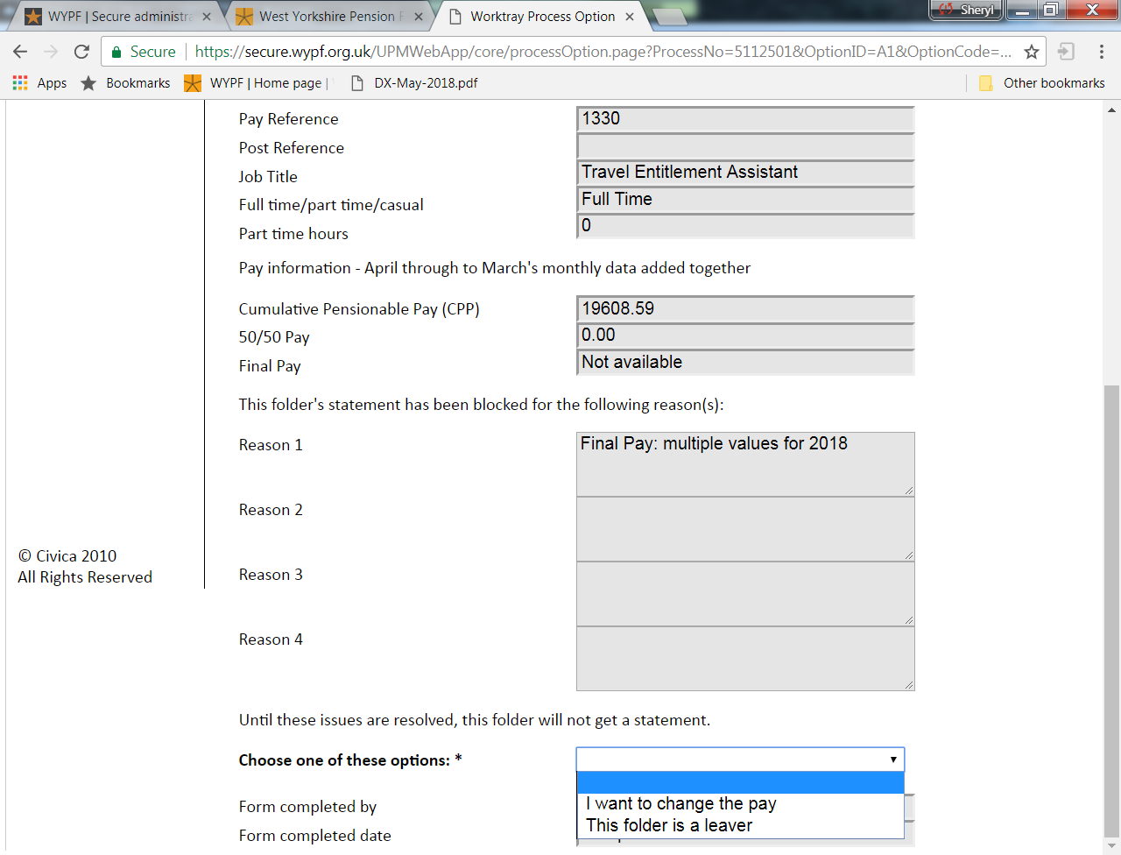

The example above explains the reason for the block (Final Pay: multiple values) and then gives you the following options below (Change pay or they are a leaver).



**The Reply Options**

I want to change the pay

Tell us the **annual** amounts for Final Pay, Main Section Pay (CPP) and 50/50 Section Pay you want us to use for the pension statement.

We don’t need to know why they’re different to what you’ve already given us, just tell us the revised values.

The options automatically default to “No”. Select “Yes” next to the pay you want to change. If you leave the option as “No change” that means the values you’ve already given us are correct.

For example, where only the Final Pay is wrong or missing, the form might end up looking like this:

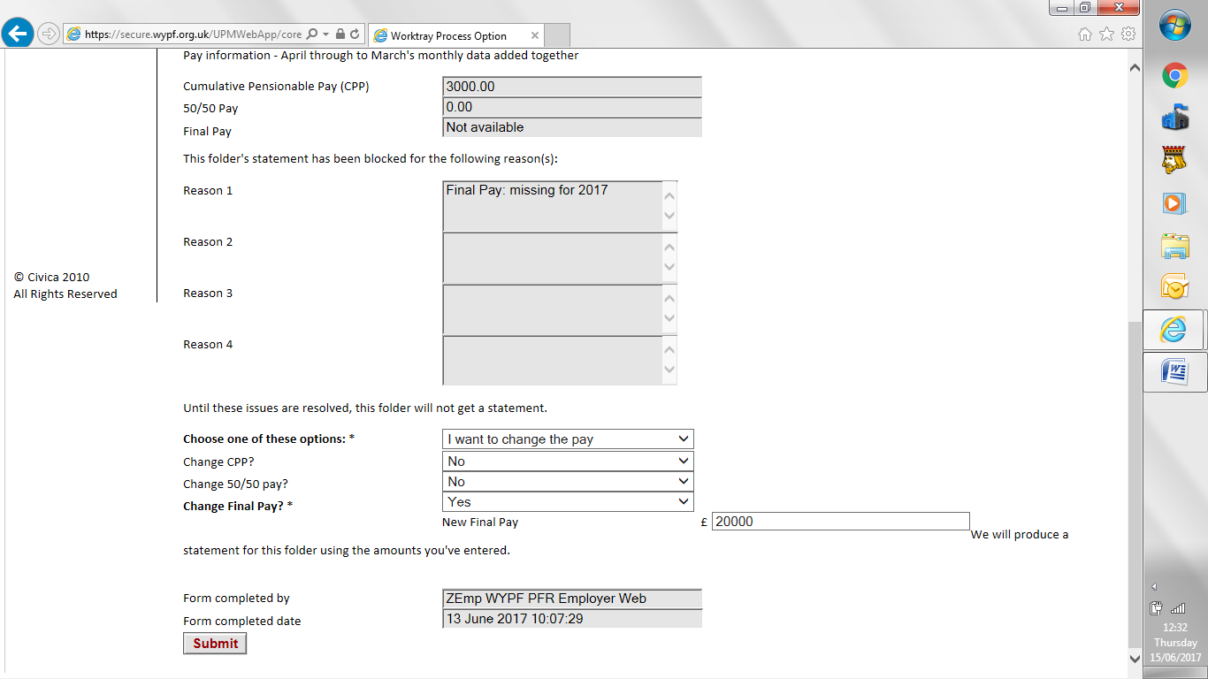

**Note:** you won’t get asked about Final Pay if that member’s pension record doesn’t have any membership before 1.4.2014.

Once you have submitted the new pay figure a Pension statement will be produced using the new information and sent to the member.

This folder is a leaver

Use this to tell us the member left that particular job during the year.

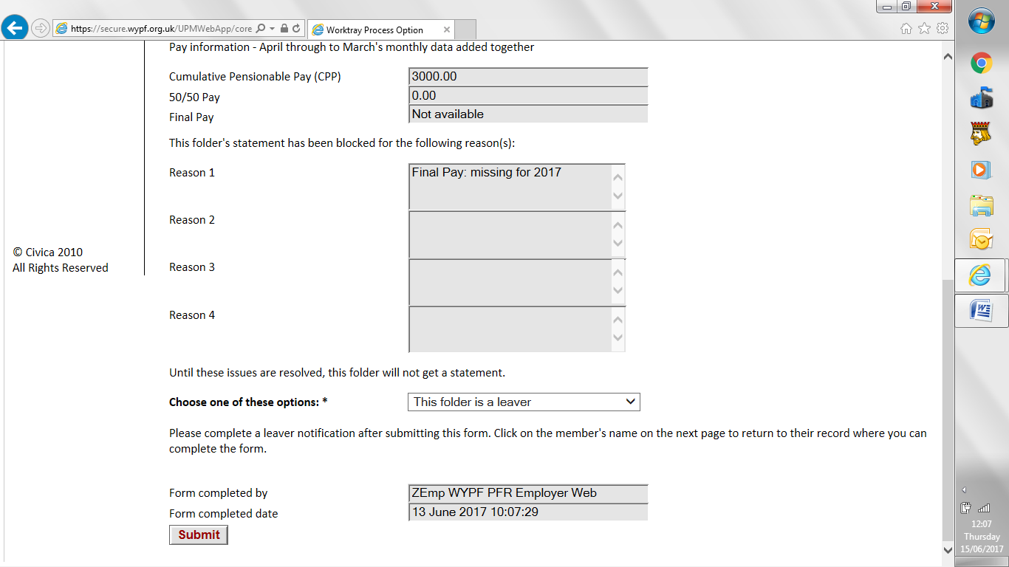

Once you click submit the process will ask you to click on the member’s name, which will be in bold above the stage instructions. Once selected, it will open a separate browser where you can complete a leaver notification within the member’s pension record.

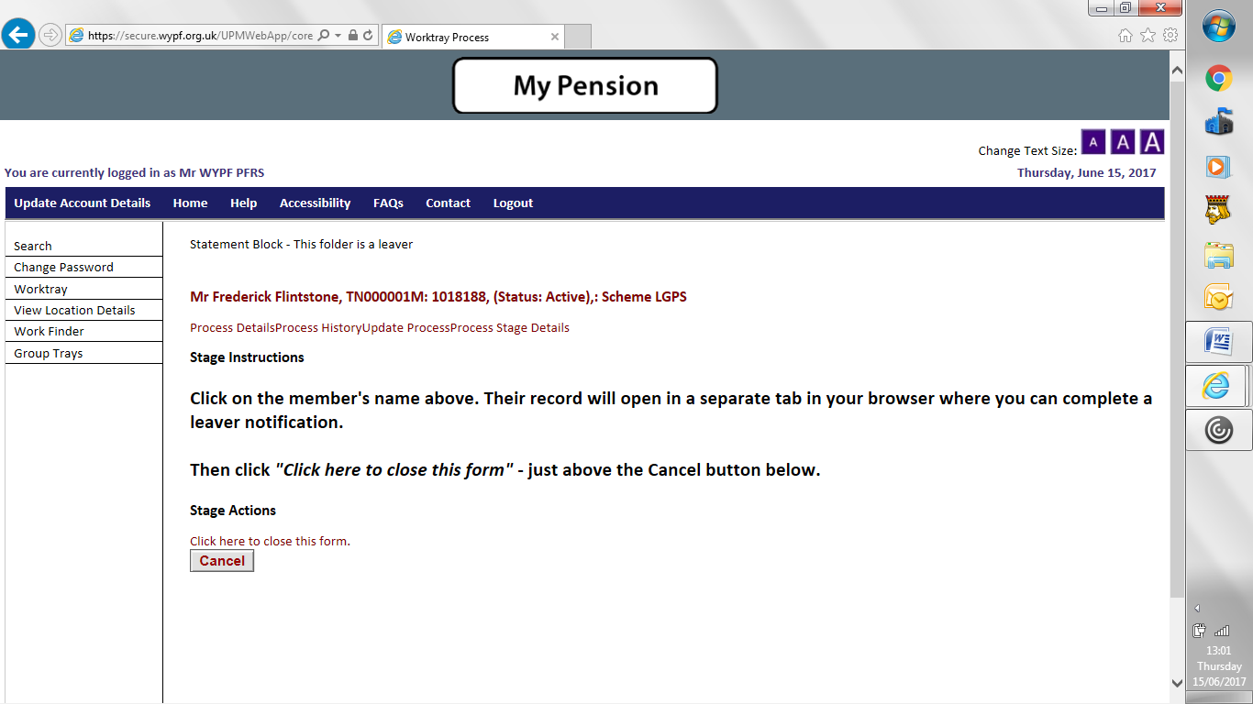

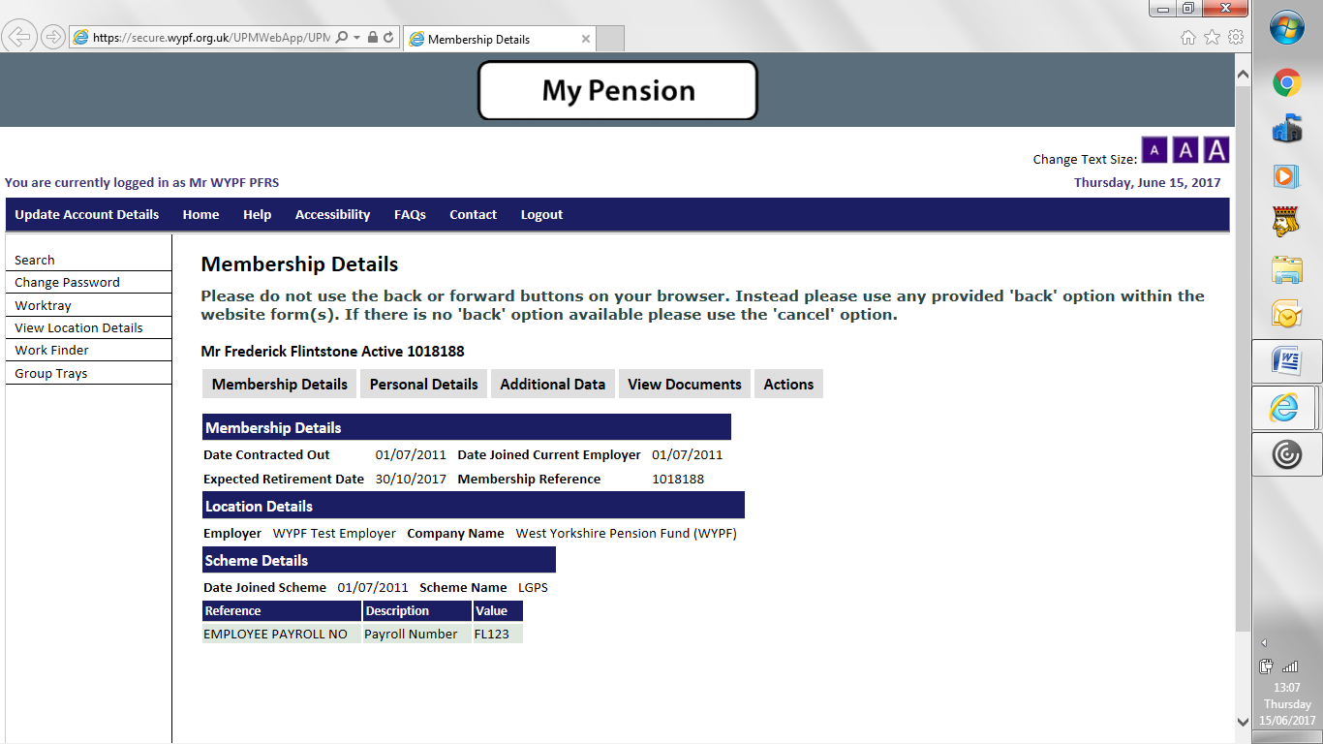

**Don’t forget to close the form created from the Pension Statement query process in your original browser.**

You can do this by selecting “Click here to close this form” – just above the Cancel button.

**An example of a Pension Statement Quarantine**

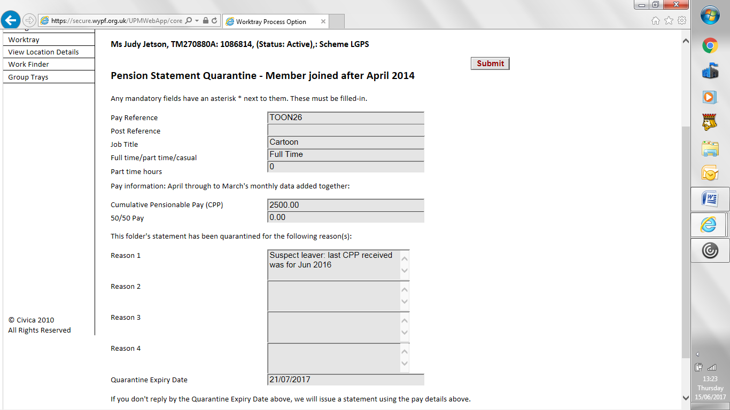

The example above explains the reason for the quarantine (last CPP received Jun 2016) and then gives you the following options below (All pay is correct, Change pay or they are a leaver).

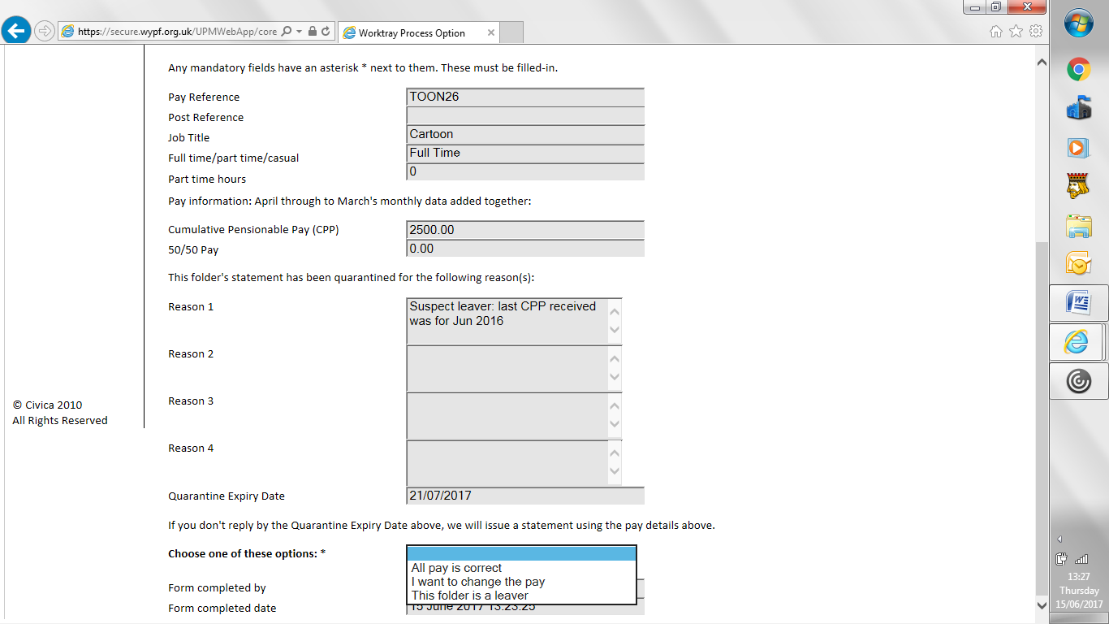

All pay is correct

Use this option to tell us that the information you’ve already given us is, actually correct. We don’t need you to tell us why this member should have passed our data checks, just confirm the financial values are right.

Once you click submit, we’ll then produce the member’s pension statement using these values.

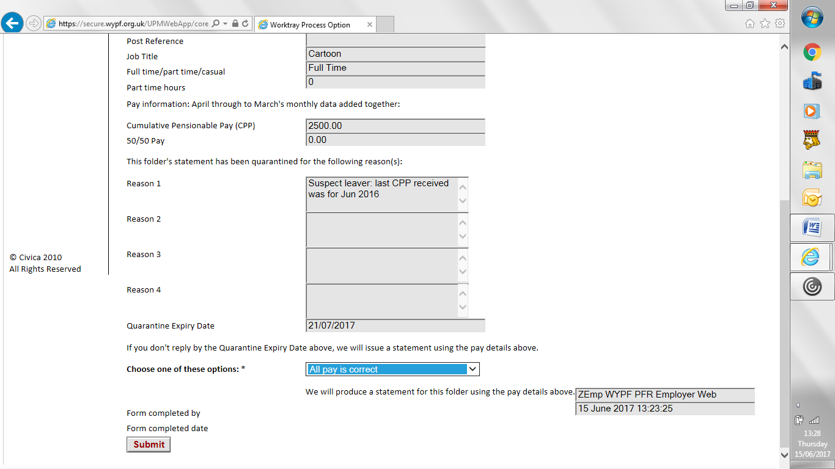

**Note:** you won’t see this option for some Pension Statement Block cases, as we don’t have all the information we need to produce a pension statement, so you can’t tell us what we’ve already got is ok. For example, where the Final Pay is missing. These types of cases will only have 2 available options: I want to change the pay or this folder is a leaver

I want to change the pay

Tell us the **annual** amounts for the pay you want to change.

We don’t need to know why they’re different to what you’ve already given us, just tell us the revised values.

The options automatically default to “No”. Select “Yes” next to the pay you want to change. If you leave the option as “No change” that means the values you’ve already given us are correct.

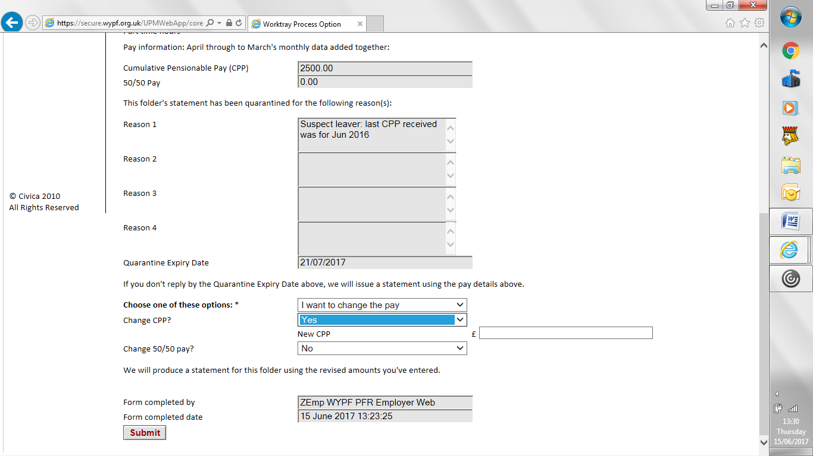

After filling in the form, click **Submit**. The process will take you back to your work tray.

We will produce a revised statement using the new pay information you have provided.

This folder is a leaver

Use this to tell us the member left that particular job during the year.

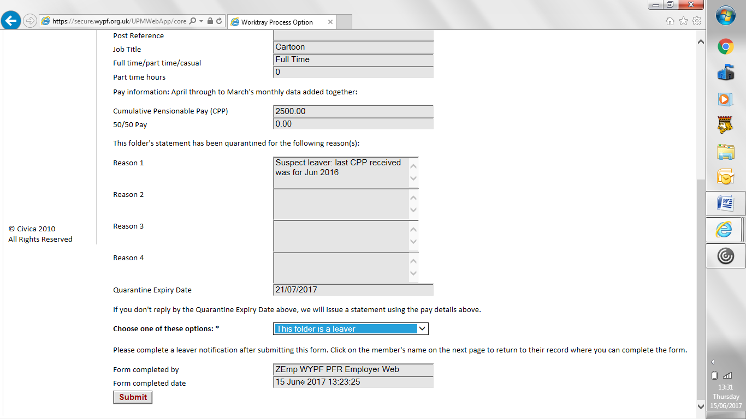

Once you click submit the process will ask you to click on the member’s name, which will be in bold above the stage instructions. Once selected, it will open a separate browser where you can complete a leaver notification within the member’s pension record.





Don’t forget to close the form created from the Pension Statement query process in your original browser.

You can do this by selecting “Click here to close this form” – just above the Cancel button.

**Troubleshooting**

Options not appearing from drop down menu.

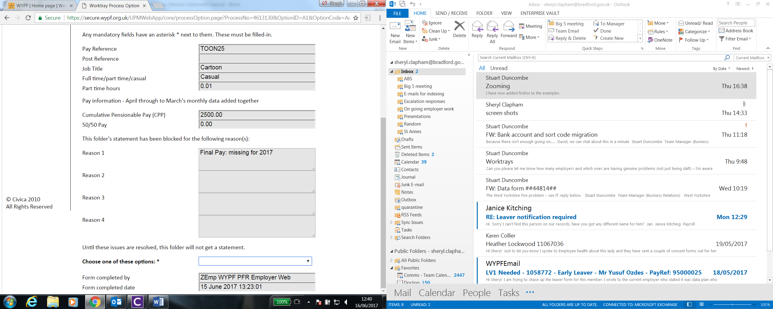

Depending on which browser you are using, will depend on how you access your settings.

Please change your zoom settings to show 150%

**Chrome**

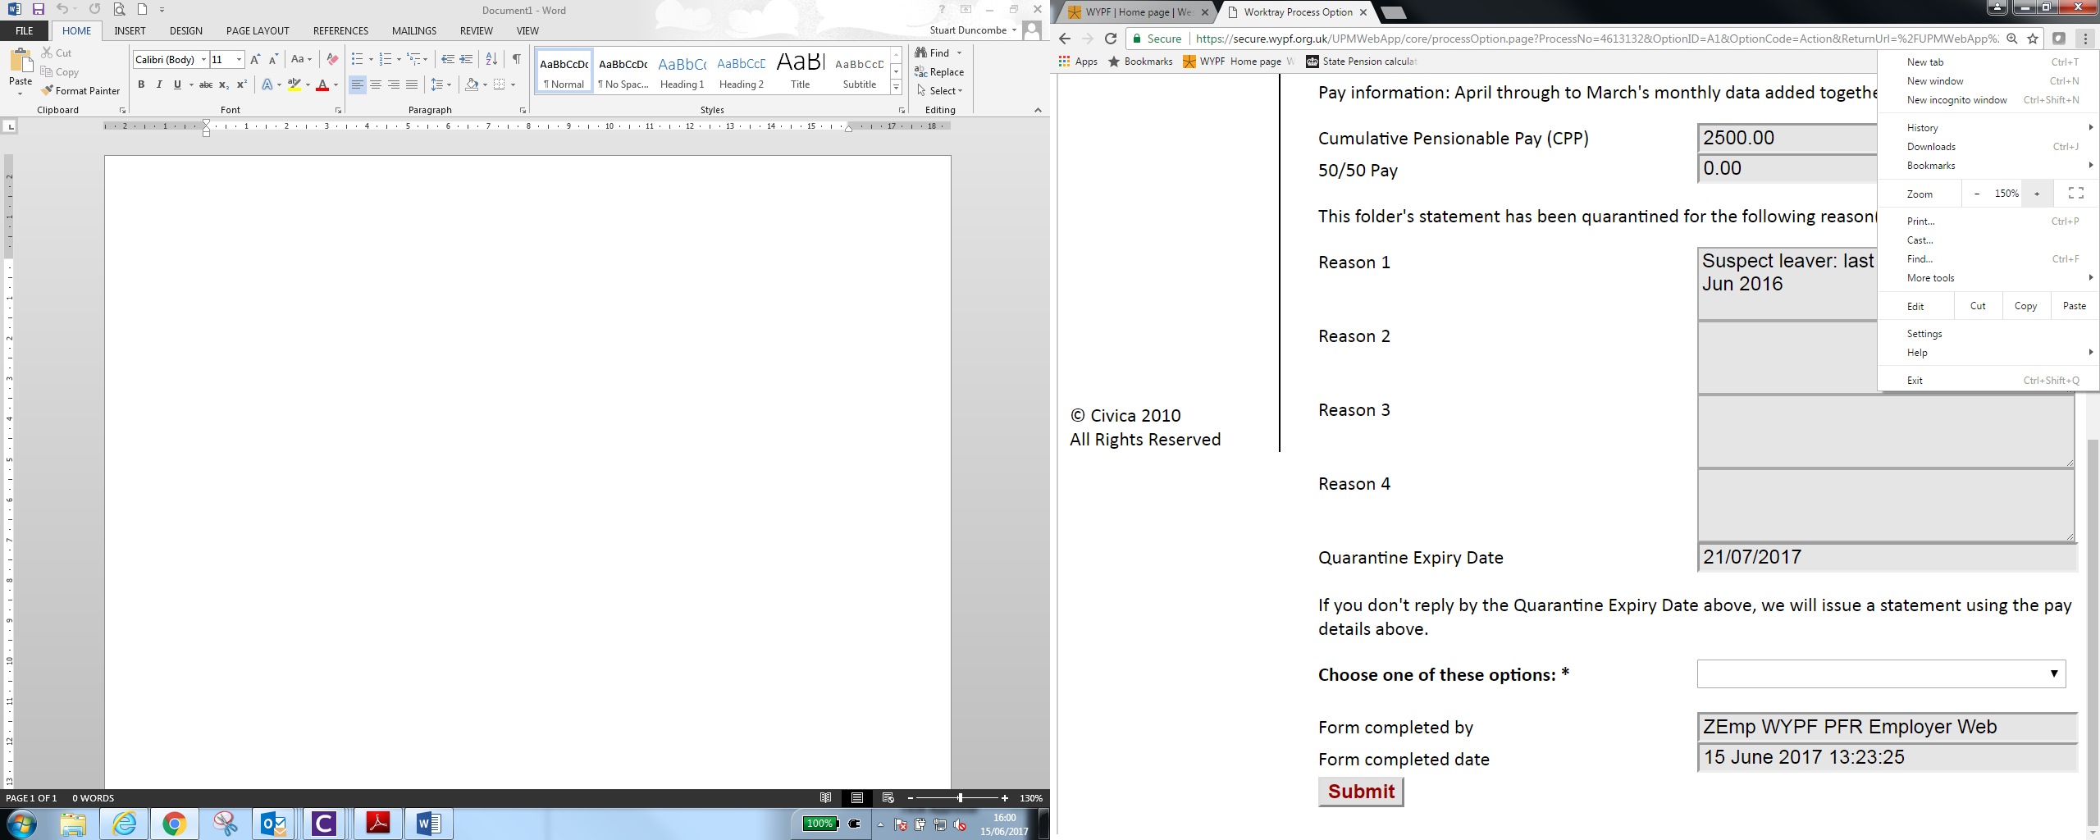

**Internet Explorer**

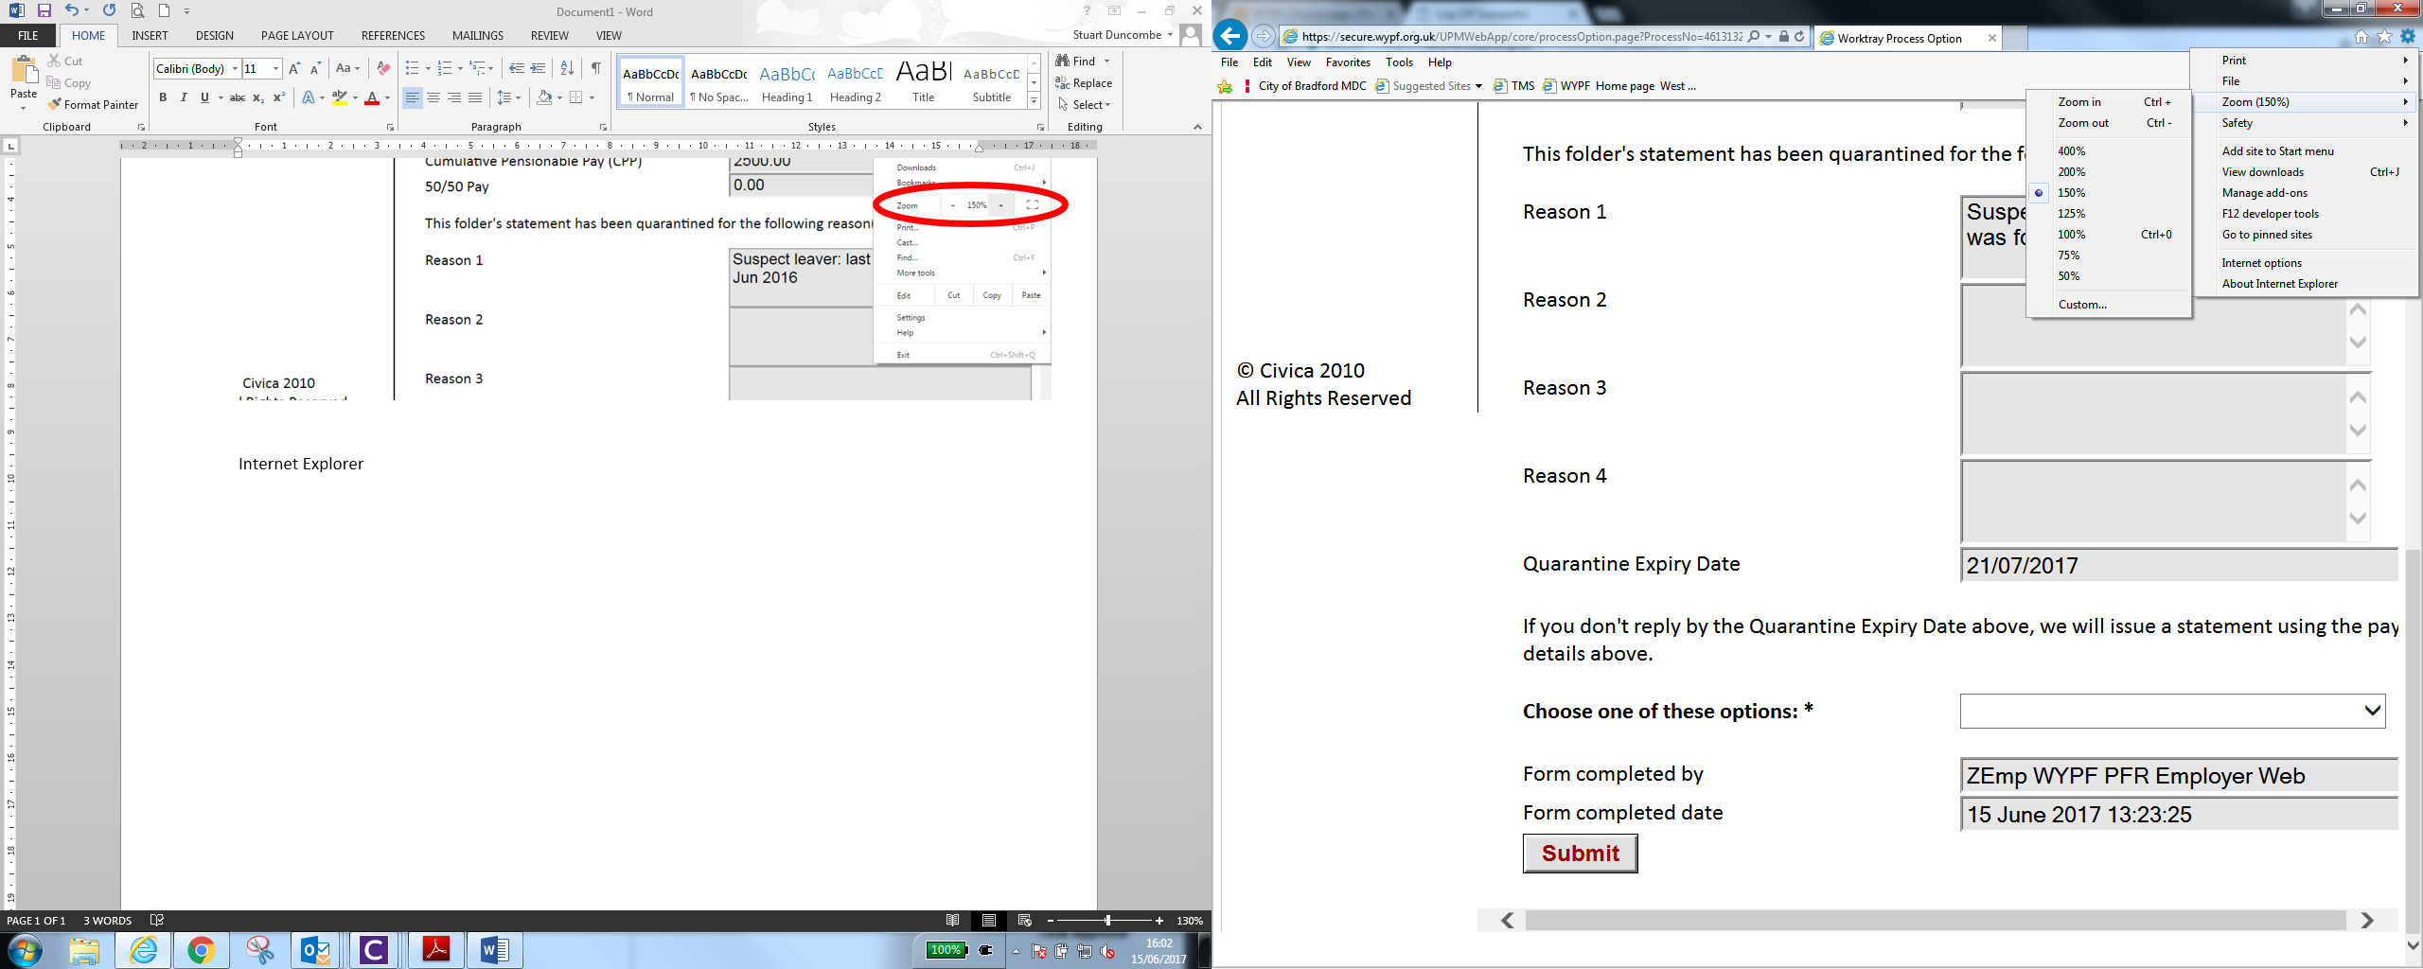

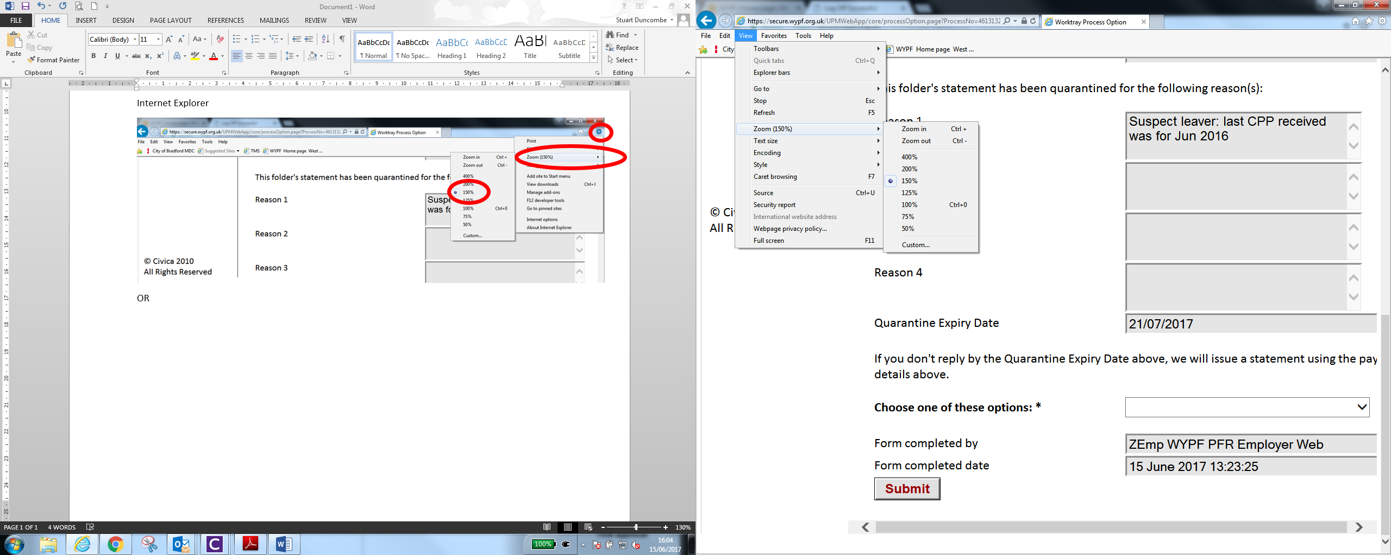

**Firefox**

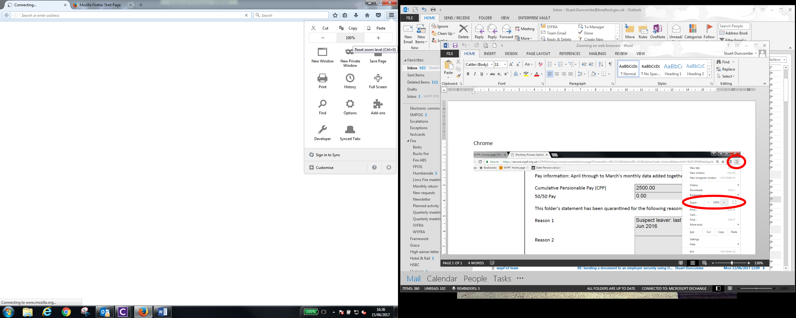

**Worktray limits**

The maximum number of items (processes) allowed in an individual worktray is set to 200